Chapter 1

**INTRODUCTION**

**INTRODUCTION**

**1.1 General**

It is sometimes thought that water flows through underground rivers or that it collects in underground lakes. Groundwater is not confined to only a few channels or depressions in the same way that surface water is concentrated in streams and lakes. Rather, it exists almost everywhere underground. It is found underground in the spaces between particles of rock and soil, or in crevices and cracks in rock.

The water filling these openings is usually within 100meters of the surface. Much of the earth's fresh water is found in these spaces. At greater depths, because of the weight of overlying rock, these openings are much smaller, and therefore hold considerably smaller quantities of water.

Groundwater flows slowly through water-bearing formations (aquifers) at different rates. In some places, where groundwater has dissolved limestone to form caverns and large openings, its rate of flow can be relatively fast but this is exceptional.

Many terms are used to describe the nature and extent of the groundwater resource. The level below which all the spaces are filled with water is called the **water table**. Above the water table lies the **unsaturated zone**. Here the spaces in the rock and soil contain both air and water. Water in this zone is called **soil moisture**. The entire region below the water table is called the **saturated zone**, and water in this saturated zone is called **Groundwater**.

Groundwater is the source of about 90% of the country’s drinking water. In rural areas, almost all the water supply comes from groundwater and more than one-third of our 100 largest cities depend on it for at least part of their supply. Historically, groundwater has been considered to be safe to drink.

However, of late groundwater is becoming contaminated with industrial effluents discharged on land and septic systems, as well as illegal and uncontrolled hazardous waste sites are involved in contaminating the ground water. Once contaminated it is difficult if not impossible to restore the groundwater.

The total quantity of groundwater on Earth is estimated as more than 50 million cu.km of this, 4million cu.km. are considered as a reasonable quantity of fresh water, that could be exploited, which excludes water that will not drain from small pore spaces, saline water and water lying deep in confined aquifers.

The total groundwater reserves of India up to a depth of 300 meters are estimated to be at 3,700 million-hectare meters (mham) and the usable groundwater at around 42mham, per year. Out of this, 27.37% is exploited. The state of Andhra Pradesh has a usable potential of 2.21mham/y.

In addition, ground water supplies are being stressed by increasing demand for water as the world’s population continues to grow and communities seek short-term solutions to this rising demand. As demand for potable water increases and as supplies decrease, ground water may be relied upon more heavily as a source. Consequently, the availability of ground water now and in the future will be important; overuse of ground water may result in serious shortages in many areas, especially in water-scarce regions.

With the ever-increasing pressure of human population, there is severe stress on water resources. It is becoming scarce in rural as well as urban areas mainly due to reduction in infiltration rate as a result of deforestation in rural areas and large scale paving of the surface in urban area. In India, though a huge quantity of surface water is available, the topography and other factors limit the storage of this water. Where the surface water is scarce, ground water assumes importance in the context of water supply as an alternative source. Due to over-exploitation of ground water in many areas the ground water levels show a declining trend, which in turn tends to increase both the investment cost and the operational cost.

Groundwater is the world's largest source of fresh water. It is estimated that the amount of groundwater is 400 times greater than all the surface water in lakes, reservoirs, streams, and rivers. Groundwater is a part of the water cycle. When precipitation falls on land, some water evaporates, some flows to streams and rivers, and some seeps into the soil and is absorbed by plant roots. Excess water in the soil may percolate further down until it reaches a level known as the water table where all the pores or openings in the soil or rock are saturated with water. Water in the saturated zone below the water table is called groundwater. Most of the spring and mineral water supplies are obtained from groundwater resources.

Ground water acts as a reservoir by virtue of large pore space in earth materials. It also acts as a conduit, which can transport water over long distances, and as a mechanical filter, which improves water quality by removing suspended solids and bacterial contamination forming main source for rural domestic use.

It is replenished or recharged by precipitation through rain, snow sleet and hail. In some areas of the world, people face serious water shortage because groundwater is used faster than it is naturally replenished. In other areas groundwater is polluted by human activities.

**1.2 INDIAN SCENARIO:**

In India, there is severe stress on water resources with the ever increasing human population. The population in India is increasing at an annual rate of 1.7crores and by the year 2050 it is said that it may cross 150crores. In India, out of an annual rainfall of 4000 billion cubic meters in an area of 329 million hectares, 41 % (10,02,04 million) is retained as soil moisture and 9% (2,19,96 million) seeps in for recharging groundwater.Of the 40 % stream flow water, 8 % is used for irrigation, 2 % for domestic use, 4 % for industries, and about 12% for electricity generation.

India will be requiring about 1,2010,00 million cubic meters of water in the year 2050 A.D. to cater to the needs of about 150 crores population for food production, drinking water, domestic, industrial, navigational, environmental and ecological requirements due to which there is a great need to conserve water (Anjaneyulu, 2003).

**Vital information:**

* Vijayawada city is one of the fastest growing.
* It has a metropolitan region comprising of 61.88 sq. km.
* It is administered by an Urban Development Authority.
* It has total Population around 1,048,240 people.
* It has total area of 61.88 sq.km

Aerial View of Vijayawada

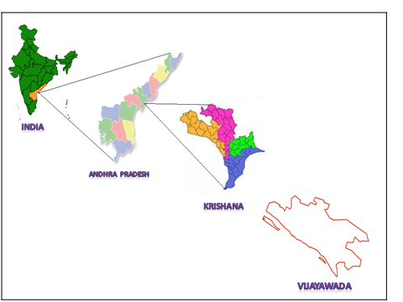

**Fig 1.1** Location Map of Vijayawada.

**Vijayawada overview**

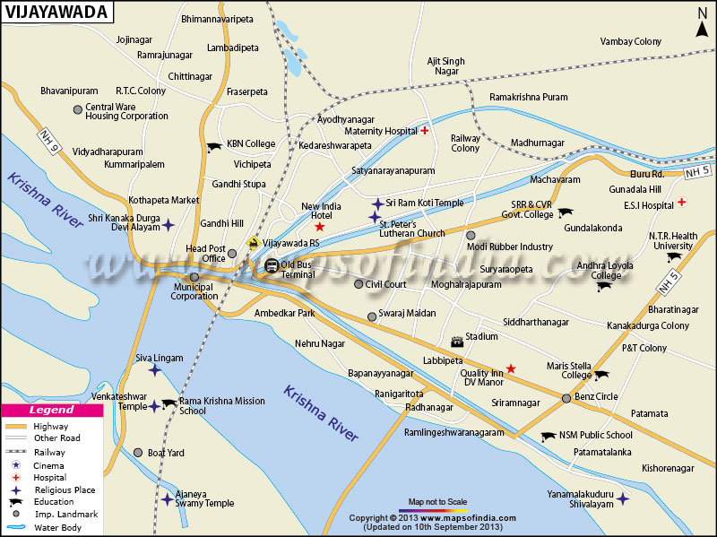

**Fig 1.2 City Map of Vijayawada.**

**Topography of Study Area of Vijayawada**

VIJAYAWADA is the third largest commercial city of [Andhra Pradesh](http://en.wikipedia.org/wiki/Andhra_Pradesh), with an area of 61.88 km2. The city municipal limits has a population of 1,048,240 (2013 Census) Location of Vijayawada in Andhra Pradesh Coordinates: [16°31′8.50″N&80°37′17.38″E](file:///\\tools.wmflabs.org\geohack\geohack.php?pagename=Vijayawada&params=16_31_8.50_N_80_37_17.38_E_type:city(1048240)_region:IN-AP)

**The city today:**

* Total area : 61.88 sq. km.
* Population : 1039518
* Males : 527307
* Females : 512211
* Sex Ratio : 993
* Literacy : 86.24%
* Water supply coverage : 77 %
* Access to comprehensive sewage scheme : 20%

One of every five households does not have access to latrine facility.

(Source: MCV)

## 1.3 Objectives of the Study

1. Preparation of thematic maps using Survey of India toposheet and satellite imagery.
2. Collection of attribute data from different department of ground water.
3. Preparation of final ground water prospectous maps by overlaying base map, lithological, structural, geomorphological, hydrological maps (Integrate spatial attribute data).
4. To narrow down the area of ground water prospects for future exploration programmes.
5. Identification of recharge structure sites & locating the wells in a particular area using GIS application.
6. To create ground water maps by integrating spatial and attribute database on ARC/VIEW & GIS Platform.
7. Preparing the Method of management systems

**1.4 Procedure**

The groundwater management involves the following methods/procedures

1. Sources of Ground Water
2. Surface waters
3. Transmission of water
4. Water treatment
5. Distribution system.

**I) Sources of Ground Water**

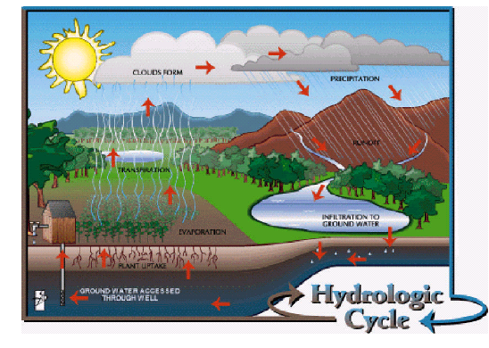

**Fig 1.3 The Hydrologic Cycle**

The origin of all sources of water is rainfall. Water can be collected as it falls as rain before it reaches the ground; or as surface water when it flows over grounds; or is pooled in lakes or ponds; or as ground water when it percolates into the ground and flows or collects as ground water; or from the sea into which it finally flows. The quantity of the water varies according to the source as well as the media through it flows.

**A.Rain water:**

Collected from roofs or prepared catchments for storage in small or big reservoirs is soft, saturated with oxygen and corrosive.

**B. Surface waters:**

(a). Natural quiescent waters as in lakes and ponds

(b). Artificial quiescent waters as in impounding reservoirs.

(c). Flowing waters as in rivers, other natural courses and irrigational canals.

(d). Waste water reclamation.

**C. Ground waters:**

a. General.

b. Springs.

**II) Transmission of water**

Water supply system broadly involves transmission of water from the sources to the area of consumption, through free flow cannels or conduits or pressure mains. Depending on the topography and local conditions, conveyance may be in free flow and/ or pressure conduits. Transmission of water accounts for an appreciable part of capital outlay and hence careful consideration of the economics is called for, before deciding upon the best mode of the conveyance. While water is being conveyed, it is necessary to ensure that there is no possibility of pollution from surrounding areas.

**Free flow and pressure conduits:**

* Open channels
* Gravity aqueducts and tunnels
* Pressure aqueducts and tunnels
* Pipelines.

**III) Water treatment:**

The main aim of treatment is to produce and maintain water that is hygienically safe, aesthetically attractive and potable, in an economical manner. Though the treatment of water would achieve the desired quality, the evaluation of its quality should not be confined to the end of treatment facilities but should be extended to the point of consumer use.

The method of treatment to be employed depends upon the nature of raw water constituents and desired standards of water quality. The unit operations in water treatment include aeration, flocculation (rapid and slow mixing) and clarification and filtration, disinfection, softening, deferrization, defluoridation and water conditioning and many different combinations of these to suit these requirements.

**Chapter 2**

**LITERATURE REVIEW**

**LITERATURE REVIEW**

G.VENKATA RAMANA, Centre for Water Resources, JNTU, Masab Tank, Hyderabad have done the project study on “Sustainable Development of Watersheds using ’’through Remote sensing and GIS. An important aim of the present study is the integrated development of Natural Human resources for sustainable development, has made Remote Sensing technology an inevitable tool in the sustainable development and utilization of our natural resources using Survey of India toposheet on 1:50000 scale drainage surface water bodies was carried out. By Visual interpretation of False Colour Composite (FCC) geocoded image of IRS-1 B. The digital data of IRS-1 B satellite together with the toposheet and rainfall data of the study area used for analysis. Evaluation study was taken in Chevella watershed in the South-West part of the Rangareddy district.

By using Image Processing Techniques the digital data is interpreted to prepare land use/ land cover map in association together with ground truth observations made in the study area. However the regional gradients, quantum of runoff and local topographical positions predominantly guided the location of these structures in the investigating area by the Remote Sensing Techniques. To assess the impact of the soil and water conservation structures on ground water region fourteen observation wells were chosen in the watershed and water levels in these wells were analyzed. The analysis revealed that water levels are raised in the watershed. This is attributed to the fact that the runoff and water retained by various soils and water conservation structures with in the watershed boundaries in the long run helping the recharge of ground water and improving the quantity of ground water in the watershed.

Sri S.K. Srivastav have done project work on” Geomorphological and Ground Water Study in Eastern Doon Valley and its surrounding” Indian Institute of Remote Sensing (NRSA). The present study has been undertaken to study the geomorphology and delineates the prospective ground water sources

in the Eastern Doon valley, and its surroundings falling in the newly formed state of Uttaranchal for this purpose, the

satellite imagery (PAN and LISS III) provided by IRS have been digitally enhancedusing various techniques to improve the visual interpretability. These enhanced images were visually interpreted to group different landform and geomorphic units existing in the area and to understand the process of their evolution other parameters which control the occurrence and movement of ground water, such as Lithology / Rock type, Structure Land use/Land-cover, drainage density were also interpreted using satellite imagery in conjunction with the existing maps and literature, and different overlays were prepared. Well data were collected from different government departments and analyzed. Based upon the well data, different maps like static water table map aquifer thickness map, well discharge map, and well yield factor map were prepared.

K. S. R. Murthy has done project study on “Groundwater potential in a semi-arid region” of A.P. using GIS. Continuous and adequate supplies of potable water from ground reservoirs are important for sustained agriculture, industry and domestic use throughout huge semi-arid regions of India. The present paper describes an approach to investigating groundwater potential over extensive geographical areas and illustrates its potential with reference to watershed planning in the large Varaha River Basin (VRB), Andhra Pradesh, India. The method involves the creation of a systematic database of information from satellite data for reconnaissance survey before going for field exploration. Colour composite images from Landsat Thematic Mapper and Indian Remote Sensing (IRS) satellite were used to interpret various thematic maps of the Varaha river basin. SPOT 1 MLA data of band 3 on a 1:250 000 scale was used for improving the accuracy of interpretation of topographic units due to its higher resolution and stereo coverage. Slope and other coverages were derived from topographic maps.

The thematic and topographic information was digitized and ERDAS Imagine GIS software was used to analyze this information.

Groundwater potential zones were delineated through subjective weights assigned to interpreted thematic and derived topographic units according to their likely infiltration capacities. Seven categories of groundwater potential ranging from very good to poor were derived automatically.

Field measurements were then madewithin a selection of these categories to check the groundwater potential at selected sites. The validity and effectiveness of using remote sensing and GIS techniques for improving the targeting of field observations for groundwater for a huge river basin is shown by comparing the inferred groundwater potential with the field measurements.

Y.SrinivasaRao, Department of Geology, S. V. University, Tirupati, and *et.al*, have done project study on ‘Hydro geomorphological studies by Remote Sensing application in Niva river basin, Chittor District, A.P’. To evaluate the hydro geomorphological conditions of Niva river basin Chittoor district, Andhra Pradesh, geological, hydrogeological and geomorphological studies were carried out, through visual interpretation of Land sat 5, FCC with adequate ground truth. The study shows that the Niva river basin is occupied by granites and gneisses of Archaean age with intrusive bodies of dolerites. The recent alluvium deposits are present along the stream courses. The study area is transverse by various directional fractures/lineaments and most of them are NE-SW, ENE-WSW and EW directions. Ground water potential of geomorphologic units viz , Denudation hill, Residual hill, Pediment, Pedi plain and valley fill. The study was carried out in Niva river basin by using Land sat 5, FCC generated bands 4,5&7 path & row 143-051 of 15th Feb, 1989 on 1:50,000 scale.

Drainage map of the basin was prepared from toposheet No’s 57 O/6 and 57 K/16, of survey of India on 1:50,000 scale. This map was super imposed on the satellite imagery of the same area.

The imagery was visually interpreted by using standard interpretation keys such as colour, tone, texture, pattern of drainage, shape and topography etc. to prepare geomorphological map. All the conventional information such as geological, hydrogeological, well inventory data and also the information collected during field checks was used in the finalization of the hydro geomorphological map.

Reliable and accurate mapping of areas affected by water logging with its location and extent can be extremely useful in chalking out suitable water management strategies to control water logging and also to undertake remedial

measures to reclaim already waterlogged land. Remote Sensing techniques have shown immense scope for providing a quick inventory of waterlogged area &its monitoring (Sahai et. al. 1982 &Sidhu et. al. 1991). Choubey (1996) stated that a rapid and accurate assessment of the extent of waterlogged areas can be made using remotely sensed data. He determined the waterlogged area in IGNP Stage I from IRS IA LISS II FCC imageries of April 19, 1989 and October 12, 1989. Attempt was also made to correlate the IRS-1A derived waterlogged area with the available water depth and electrical conductivity data to assess the area sensitive to water logging.

Sharma (1996) has stated that remote sensing and geographical information system (GIS) can be used separately or in combination with hydrological models. In his study of Arides Mountains, Argentina he has used all the techniques remote sensing, GIS and hydrological modeling successfully. With the aid of these techniques, it is possible to develop better regional model of hydrological processes in a drainage basin. Arora&Goyal (2002) discussed various causes of water logging in IGNP Stage I as high water allowance, excessive seepage from canals, continuous ponding of Ghaggar depressions, lack of use of ground water for irrigation and absence of natural drainage outfall, etc. They concluded that a comprehensive socio-economic survey mustbe undertaken to visualize negative socio-economic aspects of water logging.

Fayer et al. (1995) carried out a study to estimate the recharge using GIS. It was used to identify all possible combinations of soil type and vegetation and to assign to each combination, an appropriate estimate of recharge. Procedures to assess erosion in a catchment in Northwest Iran were evaluated using GIS and Remote Sensing (Meijerinket al.1996). The spatial segmentation of the catchment and derivation of the physical parameters related to erosion in the cells are performed through a GIS technique using the Integrated Land and Water Information System (ILWIS) package (Kothyari 1997). Rahman et al (1997) evaluated an alternative methodology for producing soil maps through a process of model construction and projection into a map base using ARC/INFO geographical information system.

Arora & Goyal (2003) highlighted the use of geographical information system (GIS) in development of conceptual groundwater model. Various layers of information such as canal network recharge zones, subsurface geology and digital terrain model (DTM) of Hanumangarh and Sriganganagar districts were developed in GIS and were then transferred to finite difference grid for developing mathematical groundwater flow model of the area.

**Chapter 3**

**METHODOLOGY**

### Methodology

### 3.1 MethodologyProcedure

1. Collection of source data like satellite data of two seasons, SOI (Survey of India) toposheet, village maps and tentative soil erosion maps. These are the main inputs for the preparation of thematic layers.
2. Two seasons’ satellite data of PAN (Panchromatic) and LISS-III (Linear Image Self Scanner) are geometrically corrected and enhanced. Then both PAN and LISS III data are merged using principal component method and Cubic Convolution resampling technique. Finally after map composition satellite imagery is printed in FCC in 1:50,000 scale.
3. Preparation of basic themes like base map, settlement map, village map, drainage map and soil erosion map from the source data. Then updating of base map, transport map and drainage map from the satellite image by visual interpretation.
4. Thematic maps (related to natural resources) like land use / land cover map, Lithology map, structure map and geomorphology map are prepared by visual interpretation of the satellite imagery. Visual interpretation is carried out based on the image characteristics like tone, size, shape, pattern, texture, location, association, background etc. in conjunction with existing maps/literature.
5. Preliminary quality check and necessary corrections are carried out for all the maps prepared.
6. Field observations are incorporated in to the related thematic layers. Well status map is prepared by plotting the well inventory data on the village maps.
7. Ground water prospects map is prepared by the combination of Lithology map, geomorphology map, Command area map is prepared by the combination of land use/land cover map, primary and secondary data related to irrigation and tanks.
8. Final quality check and necessary corrections are carried out for all the maps prepared.
9. All the maps prepared are converted into soft copy by digitization. In that process editing, labelling, mosaicking, quality checking, data integration etc., are carried out.
10. Land use/land cover map, ground water prospects map, command area map are integrated with village map and analysed to get village wise statistical findings.
11. Villages are categorized by irrigation utilization, natural resources utilization based on the village wise statistical findings.
12. Ranking criteria is prepared for prioritization of villages for the developmental activities based on the available natural resources and accordingly villages are ranked and categorized.
13. Report was prepared with report generation, graphics preparation, A4 size layout preparation, and Editing / composition and Annexure preparation.
14. Preparation of Arc view project file with hotlink to all thematic maps.
15. Preparation and plotting of A4 size maps
16. Preparation of final deliverables in soft copy format for submission.

**Flow chart showing Methodology for the present study**

|  |
| --- |
| clip_image001 |

**Fig 3.2** Flow chart showing Methodology for the present study

**3.3 G.I.S:**

GIS is an acronym for Geographic Information Systems. In detail GIS are decision support computer based system for collecting, storing presenting and analyzing spatial information. An information system a set of processes executed on raw data, to produce information, which will be useful in decision making. GIS is a general-purpose technology for handling geographic data in digital form, and satisfying the following specific needs, among others.

* The ability to preprocess data from large stores into a form suitable for analysis including operation such as reformatting, change of projection, resampling and generalization.
* Direct support for analysis and modeling such that, form of analysis calibrations of models, forecasting and prediction all handled through instructions to the GIS.

Post processing of results, including such operations is reformatting tabulation, report generation and mapping.

The GIS or geographic features are combined from map features

* + - * + Point
        + Polygon
        + Line

**Components of a GIS:**Geographical information systems have important components like-

* Computer hardware
* Software modules
* The organization aspects.

**The Computer Hardware:**

The Hardware components of a GIS include – control processing unit (CPU) which is linked to mass storage units such as hard disk drives and tape drives, peripherals such as digitizer or scanner, printer or plotter and visual display unit (VDU) shows the major hardware components of a GIS.

**GIS Software Modules:**

The software package for a GIS consists of four basic technical modules.

Data input and verification

Data storage and Database Management

Data transformation and manipulation.

Data output and presentation.

**3.4 DATA STRUCTURES:**

In GIS the Data Structure is of 2 types

**A. Raster Data Structure:**It is the cellular organization of spatial data. The

Simplest raster data structure consists of an array of grid cells.

1. Simple Raster Array
2. Hierarchical Raster structures.

**B.Vector Data Structure:**Vector representation is mainly based on the three

Main geographical entities points, lines and polygon.

1. Whole polygon structure
2. Dual independent map encoding file structure
3. Arc- node structure.
4. Relational structure.
5. Digital line graphs

**3.5 SPATIAL DATABASE CREATION:**

In GIS, topology is the term used to describe the geometric characteristic of objects, which do not change under transformations and are independent of any coordinate system. The topological characteristics of an object are also independent of scale of measurement.

Topology as it relates to spatial data and non-spatial data consists of three elements, namely adjacency, containment and connectivity. Broadly, topology can be explained in two ways. Topology consists of metric aspects of spatial relations, such as size, shape, distance and direction. Many spatial relations between objects are topological in nature, including adjacency, containment and overlap. The geometric relationship between spatial entities and corresponding attributes are very crucial for spatial analysis and integration in GIS. In topology creation both the spatial and attribute data are linked from which different parameter maps are generated. These maps depict the spatial distribution of non-spatial information on spatial locations. The spatial database relevant for this study is Location map.

**3.6 ATTRIBUTE DATABASE CREATION:**

Attributes are the characteristics of the map features and hold the descriptive information about the geographic features. Attributes are the non-spatial data associated with time and area entities.

|  |  |  |
| --- | --- | --- |
| **Theme** | **Data Type** | **Description** |
| City Boundary | Polygon | City Boundary-Total 59 Wards  (As per year 2011) |
| Major Roads | Line | Major Roads like NH-5,NH-10 |
| Railway Lines | Line | - |
| Internal Roads | Line | - |
| Buildings | Point | Building types like Government, Educational,Worship,Commercial, Residential, Hotel &Emergency |

**Table 3.1. About city**

**3.7 Maps:**

**1) Base Map:**

The study area base Map is prepared by using Survey of India topographic maps on 1:50,000 scale. All the settlements, road network, water bodies and forest areas are taken into consideration. By comparing the Survey of India topographic maps with that of the satellite image the size of all the settlements are increased and updated. The aerial extent of the study area is 1171sq. km. The Base Map contains the following details.

1. Rivers/Streams
2. All water bodies both perennial and ephemeral
3. Canals
4. National highways
5. State highways
6. Metalled and unmetalled roads connecting all the habitations
7. Railways
8. Cities/major towns/villages
9. International, State, District, Taluk/Tahsil boundaries. (from Toposheet)

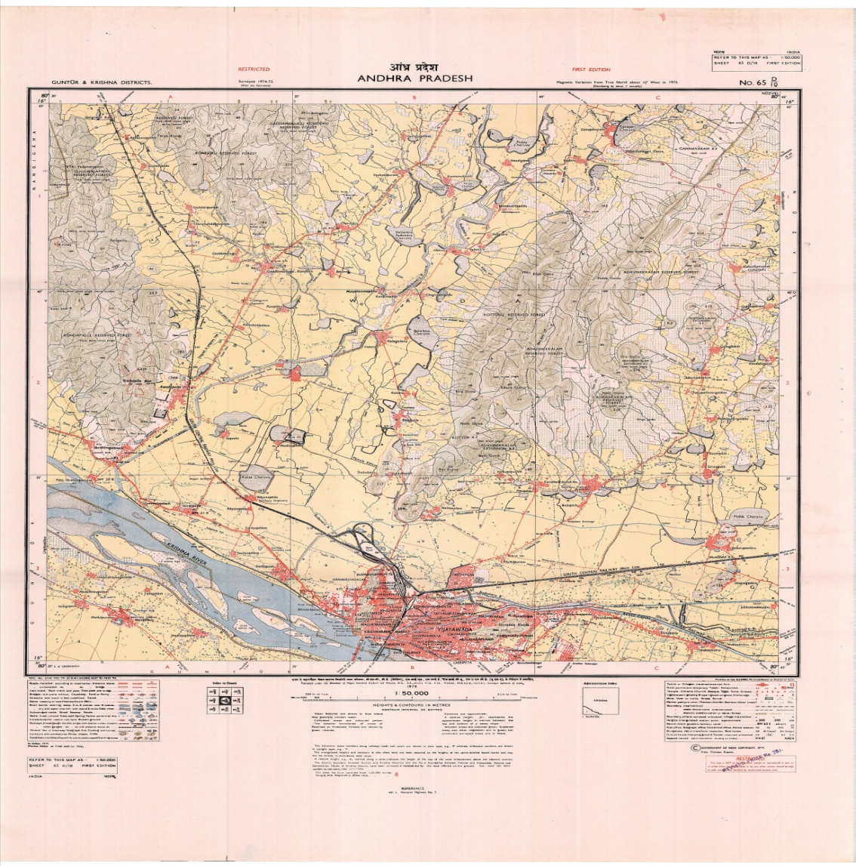

**Fig 3.3.VIJAYAWADA TOPOSHEET**

# Materials and Methods

Water samples have been collected from**Autonagar, Ayyappanagar, Patamata, Benzcircle, Labbipet, Gunadala and Machavaram** locations in Vijayawada. The collected samples were labelled properly indicating the exact position where the samples are collected. Water Samples are brought to the laboratory and analysed for parameters such as pH, Chlorides, and Total Solids, TDS, TSS and Hardness were by determined by standard methods.

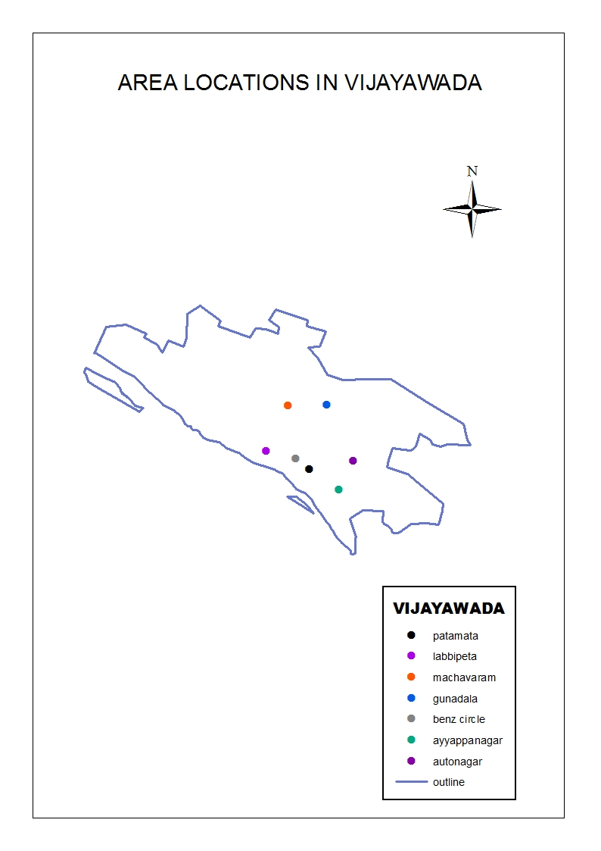

**Fig 3.4**

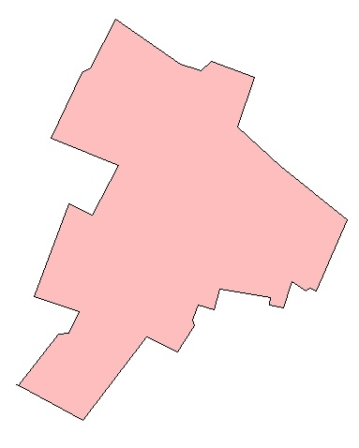

***PROJECT AREAS:* Fig 3.5**

These are the outline maps of our project areas

**AUTO NAGAR**

Wherewe have done our survey for groundwater

(Wells).

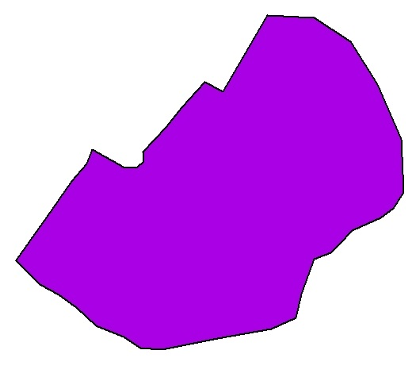

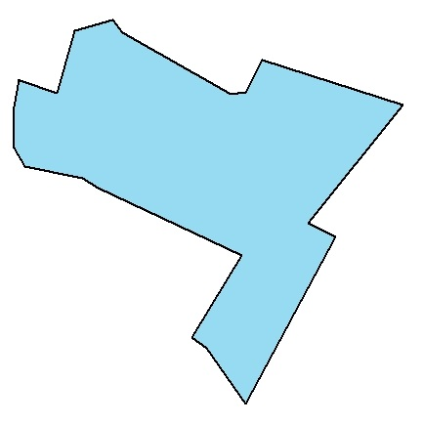

**Ayyappa nagar**

**patamata**

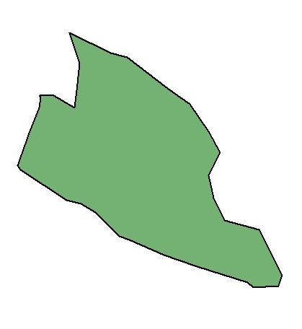

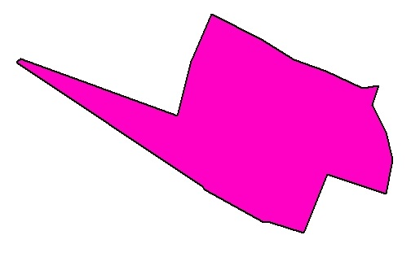

**Benz circle**

**Labbipeta**

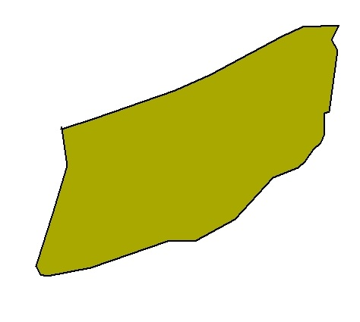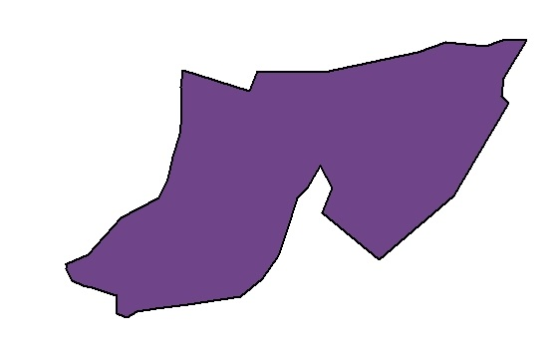

**machavaram**

**gunadala**

***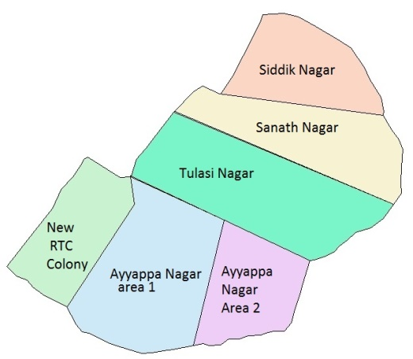WATER SAMPLES COLLECTED AREAS* (Fig 3.6)**

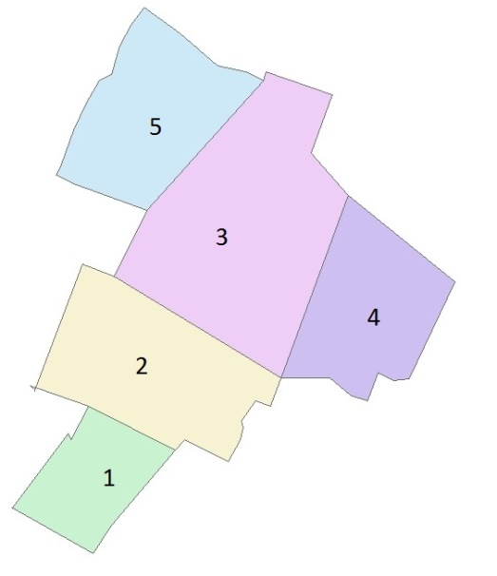

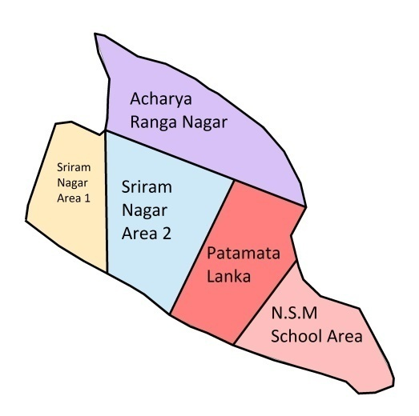

**Ayyappa nagar**

**AUTO NAGAR**

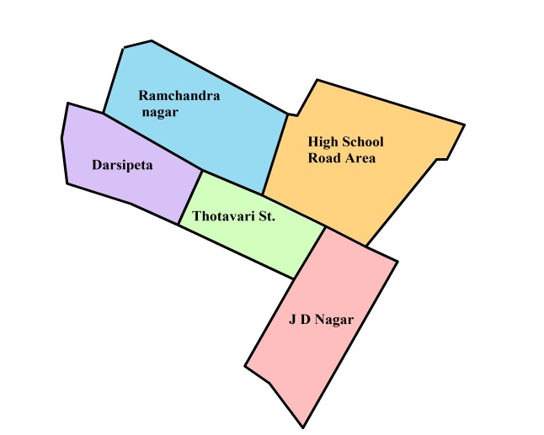

**Benz circle**

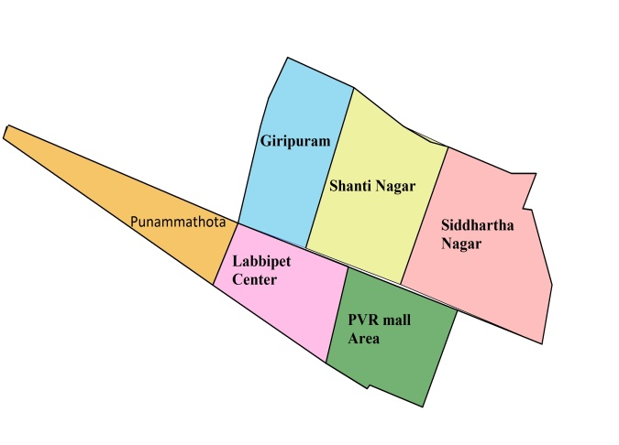

**Patamata**

**Labbipeta**

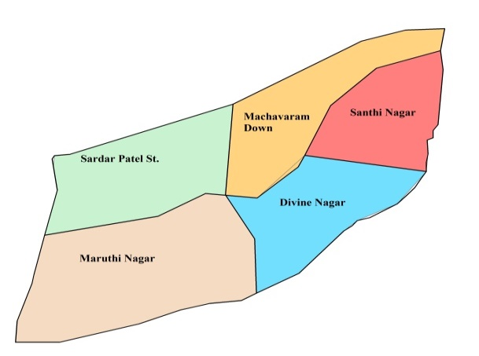

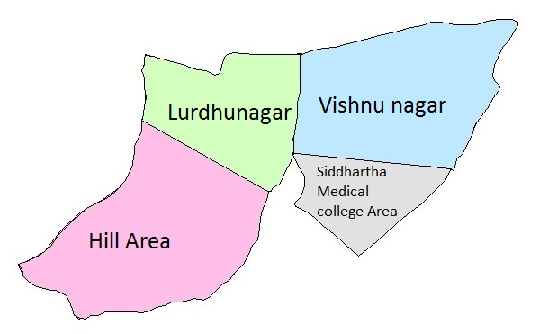

**machavaram**

**gunadala**

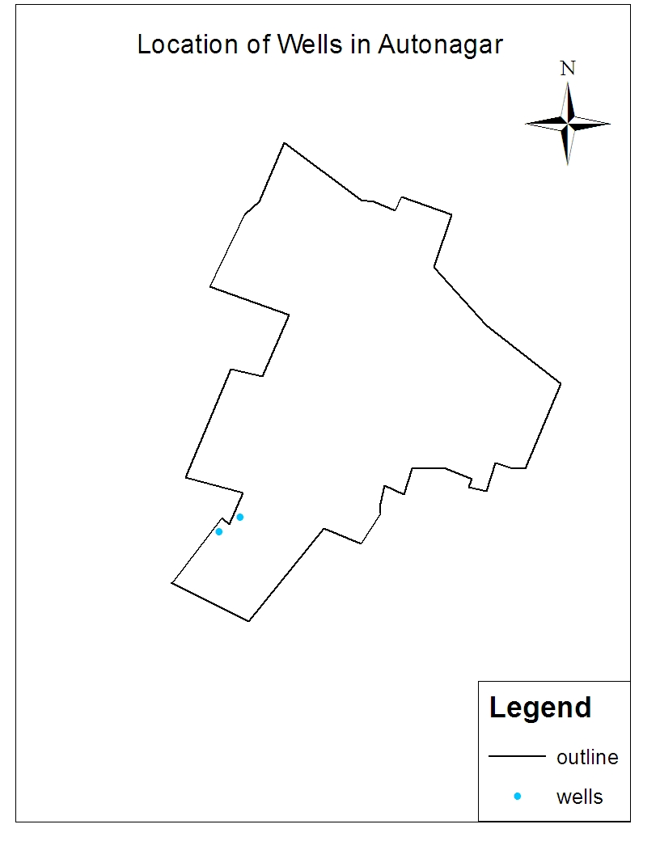

**Fig 3.7**

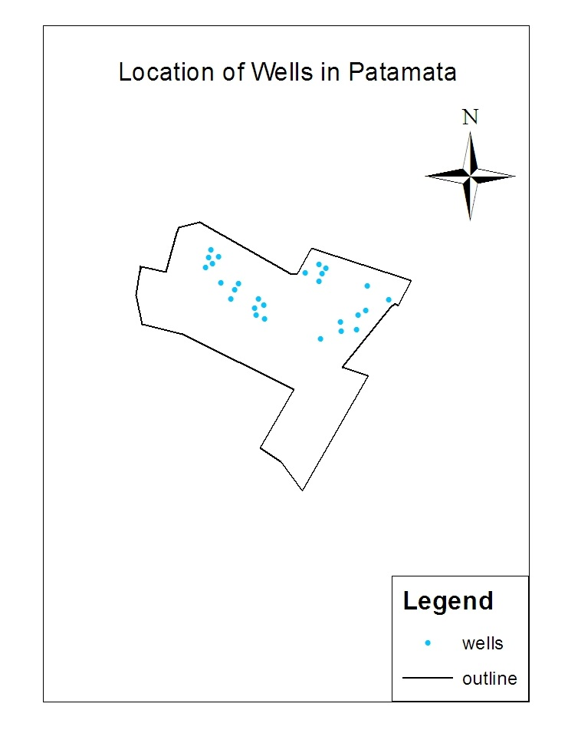

**Fig 3.8**

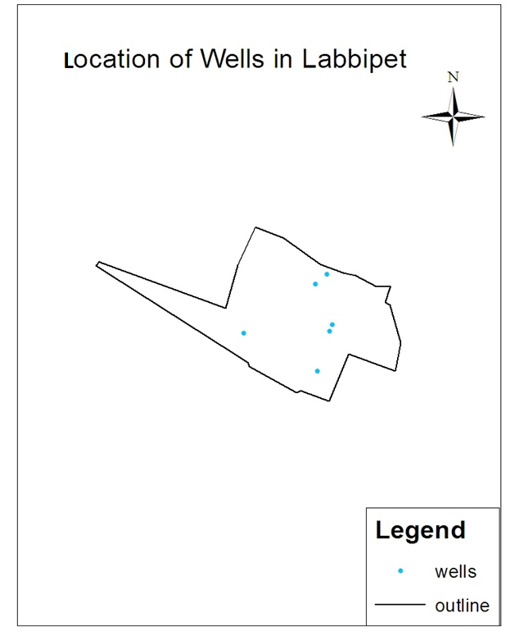

**Fig 3.9**

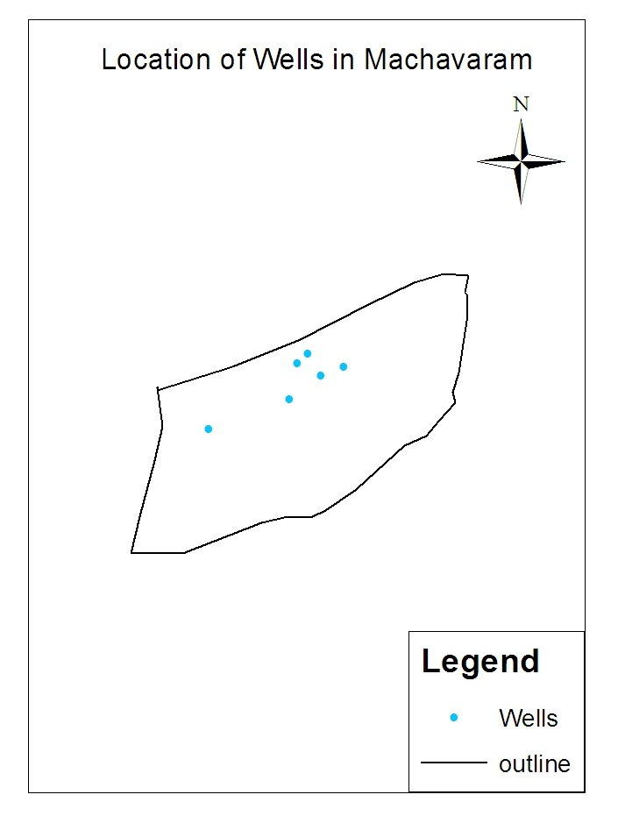**Fig 3.10**

**Chapter 4**

**METHODOLOGY**

**OF**

**WATER ANALYSIS**

**Parametric Analysis:**

The parametric analyses carried out to assess the ground water quality are broadly divided into

**Field Measurement:**

The field parameters measured include pH.

**Chemical Parameters:**

Chlorides, Hardness, Total Solids (TS), Total Dissolved Solids (TDS), Total Suspended Solids (TSS).

# Methods used for water analysis.

|  |  |  |
| --- | --- | --- |
| **Test Conducted** | **Units** | **Principle of the method** |
| PH |  | Digital pH meter |
| Total Solids | mg/1 | Evaporation |
| Total Dissolved Solids and Suspended Solids. | mg/l | Filtration and evaporation |
| Hardness | mg/1 | Titration with stand. EDTA using Eriochrome black T indicator & 1ml of Ammonia buffer Sol. |
| Chlorides | mg/l | Titration with stand. AgNO3 using K2Cr2O7 as indicator. |

**Table 4.1**

**4.1. DETERMINATION OF pH**

The effect of pH on the chemical and biological properties of liquids makes its determination very important. It is one of the most important parameters in water chemistry and is defined as -log [H+], and measured as intensity of hydrogen ion concentration on a scale ranging from 0-14. If free H+ are more it is expressed as acidic (i.e. pH<7) and if OH- ions are more then it is expressed as alkaline (i.e. pH> 7).

In natural waters, pH is governed by the equilibrium between carbon dioxide / bicarbonate / carbonate ions and ranges between 4.5 and 8.5 although mostly basic. It tends to increase during day largely due to the photosynthetic activity (consumption of carbon di-oxide) and decreases during night due to respiratory activity. Wastewater and polluted natural waters have pH values lower or higher than 7 based on the nature of the pollutant.

**Apparatus required:**

Glass electrode, Reference electrode (mercury/calomel or silver/silver chloride) and pH meter

**Procedure:**

Electrometric method: pH is determined by measuring the Electro Motive Force (E.M.F) of a cell comprising an indicator electrode (an electrode responsive to hydrogen ions such as a glass electrode) immersed in the test solution and the reference electrode (usually a mercury/calomel electrode). Contact between the test solution and the reference electrode is usually got by means of a liquid junction, which forms a part of reference electrode. E.M.F of this cell is measured with pH meter, that is, a high impedance voltmeter calibrated in terms of pH. The electrode is allowed to stand for 2 minutes to stabilize before taking reading for reproducible results (at least ±0.1 pH units).

**4.2. DETERMINATION OF TOTAL SOLIDS**

Total solids are the term applied to the residue left in the vessel after evaporation of the sample and its subsequent drying in an oven at a temperature of 103-105oC. Total solids include Total Suspended Solids (TSS) and Total Dissolved Solids (TDS).

**Apparatus:**

Evaporating dishes – 100 ml porcelain dish, steam bath, drying oven, desiccators, and Electronic balance and measuring jars.

**Procedure**:

The sum of weights of Total Suspended Solids(TSS) and Total Dissolved Solids(TDS) in same units.

(OR)

A known volume of the well-mixed sample (50ml) is measured into a pre-weighed dish and evaporated to dryness at 103 o C on a steam bath. The evaporated sample is dried in an oven for about an hour at 103-105 o C and cooled in desiccators and recorded for constant weight.

**Calculation:**

Total solids (mg/l)   =  (W1 - W2) (1000)

Sample volume (ml)

Where, W1    = Weight of dried residue + dish,

W2 = Weight of empty dish,

V= Volume taken.

**4.3. DETERMINATION OF TOTAL DISSOLVED SOLIDS**

Dissolved solids are solids that are in dissolved state in solution. Waters with high dissolved solids generally are of inferior palatability and may induce an unfavourable physiological reaction in the transient consumer.

**Principle:**

The difference in the weight of total solids and the total suspended solids expressed in the same units gives the total dissolved solids.

**Apparatus:**

Watt man filter Paper, drying oven and Gouch crucible.

**Procedure:**

The known volume of vigorously shaken sample (50ml) is filtered into a pre-weighed Porcelain dish, and Sample is dried for an hour at 103-105o C in an oven, cooled in desiccator and weighed for constant weight

**Calculation:**

Total Dissolved Solids  (mg/l)  =   (W1 - W2) x (1000)

Sample volume (ml)

W1    = Weight of total solids + dish,

W2 = Weight of total suspended solids

V= Volume of the sample.

**4.4. DETERMINATION OF TOTAL SUSPENDED SOLIDS**

Suspended solids are the portions of solids that are retained on a filter of standard specified size (generally 2.0 µ) under specific conditions. Water with high-suspended solids is unsatisfactory for bathing, industrial and other purposes.

**Principle:**

A well – mixed sample is filtered through a weighed standard glass fibre filter and the residue that is retained on the filter is dried to a constant weight at 103-105 o C. The increase in the weight of the filter determines the total suspended solids.

**Apparatus:**

Porcelain dish (100ml capacity), Watt man filter paper, flasks, measuring jar, drying oven and filtration apparatus.

**Procedure:** The known volume of vigorously shaken sample (50ml) is filtered by filter paper into a pre-weighed Porcelain dish, and Filter Paper is dried for an hour at 103-105o C in an oven, cooled in desiccator and weighed for constant weight.

**Calculation:**

Total Suspended Solids  (mg/l)  =  (W1 - W2) x (1000)

Sample volume (ml)

W1    = Weight of dried glass fibre filter + residue,

W2 = Weight of glass fibre filter disk before filtering.

**4.5. DETERMINATION OF CHLORIDES**

The presence of chlorides in natural waters can mainly be attributed to dissolution of salt deposits in the form of ions (Cl-). Otherwise, high concentrations may indicate pollution by sewage or some industrial wastes or intrusion of seawater or other saline water. It is the major form of inorganic anions in water for aquatic life. High chloride content has a deleterious effect on metallic pipes and structures, as well as agricultural plants. They are calculated by (Mohr’s) Argentometric method.

**Principle:**

In alkaline or neutral solution, potassium chromate indicates the endpoint of the silver nitrate titration of chlorides. Silver chloride is quantitatively precipitated before the red silver chromate is formed.

**Apparatus required**:  Lab glassware.

**Reagents:**Potassium chromate indicator,Silver nitrate solution (0.014N)

**Procedure:**

A known volume of filtered sample (50ml) is taken in a conical flask, to which about 0.5ml of potassium chromate indicator is added and titrated against standard silver nitrate till silver dichromate (AgCrO4) starts precipitating.

**Calculation:**

Chlorides (Cl-) =   (A-B) x (N) x (35.45)

Sample taken in ml

Where, A - Volume of silver nitrate consumed by the sample

B - Volume of silver nitrate consumed by the blank

N - Normality of silver nitrate

**4.6. DETERMINATION OF HARDNESS**

Effects of hard water are mainly due to the effects of the salts dissolved in it, primarily calcium and magnesium.

* The
* health effects of hard water are mainly due to the
* effects of the salts dissolved in it, primarily calcium
* and magnesium. To a large extent, individuals
* are protected from excess intakes of calcium by a
* tightly regulated intestinal absorption mechanism
* through the action of 1, 25‑dihydroxy‑vitamin D,
* the hormonally active form of vitamin D.
* The
* health effects of hard water are mainly due to the
* effects of the salts dissolved in it, primarily calcium
* and magnesium. To a large extent, individuals
* are protected from excess intakes of calcium by a
* tightly regulated intestinal absorption mechanism
* through the action of 1, 25‑dihydroxy‑vitamin D,
* the hormonally active form of vitamin D.
* The
* health effects of hard water are mainly due to the
* effects of the salts dissolved in it, primarily calcium
* and magnesium. To a large extent, individuals
* are protected from excess intakes of calcium by a
* tightly regulated intestinal absorption mechanism
* through the action of 1, 25‑dihydroxy‑vitamin D,
* the hormonally active form of vitamin D.
* The
* health effects of hard water are mainly due to the
* effects of the salts dissolved in it, primarily calcium
* and magnesium. To a large extent, individuals
* are protected from excess intakes of calcium by a
* tightly regulated intestinal absorption mechanism
* through the action of 1, 25‑dihydroxy‑vitamin D,
* the hormonally active form of vitamin D.

Increased soap usage in hard water results in metal or soap salt residues on the skin or on clothes thar are not easily risned off and that lead to contact irritation.

**Aim:**

To determine the total hardness of the given samples by EDTA titrimetric method.

**Apparatus:**

Burette, Erlenmeyerflask, Pipette, Bottle etc.

**Reagents:**

Standard EDTA titrant, Eriochrome black T indicator, Ammonia buffer solution.

**Procedure:**

A 50 ml of sample is taken in a flask and add 1 ml of buffer solution then add 2 or 3 drops of Eriochrome black T indicator. The solution turns into wine red colour .Now add Standard EDTA titrant slowly with continuous stirring until reddish colour disappears and converts into blue colour under normal conditions. Then note the value of EDTA run down as v1.

**Calculations:**

Hardness as CaCO3= (v1 x S x 1000)/V mg/l

Where S = mg CaCO3 equivalent to 1 ml of EDTA titrant

= 1mg CaCO3

**4.7. TEST RESULTS**

**TEST RESULTS OF AUTO NAGAR WATER SAMPLE:**

**Sub: Test Results of Water Sample for drinking purpose-reg.**

**The Results are tabulated below:**

**Area 2**

**Area 1**

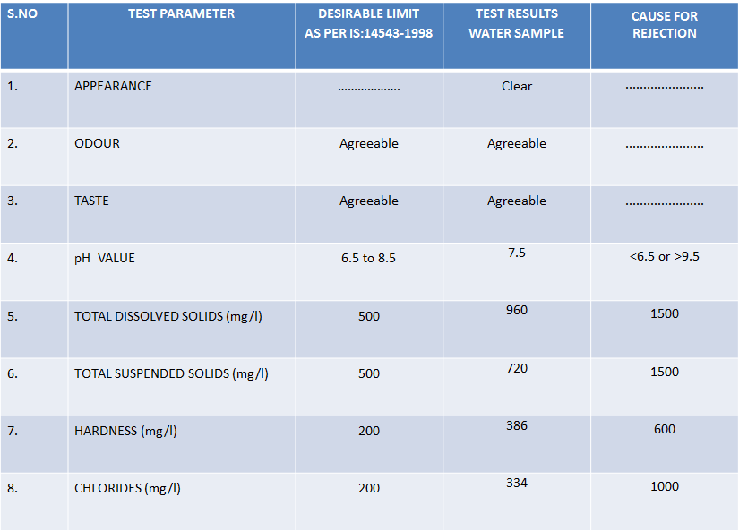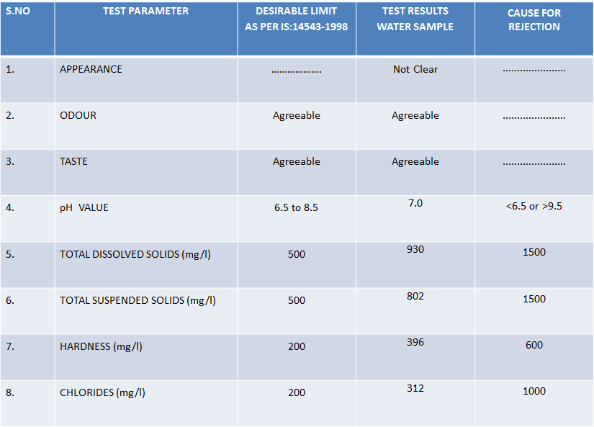

**Area 4**

**Area 3**

**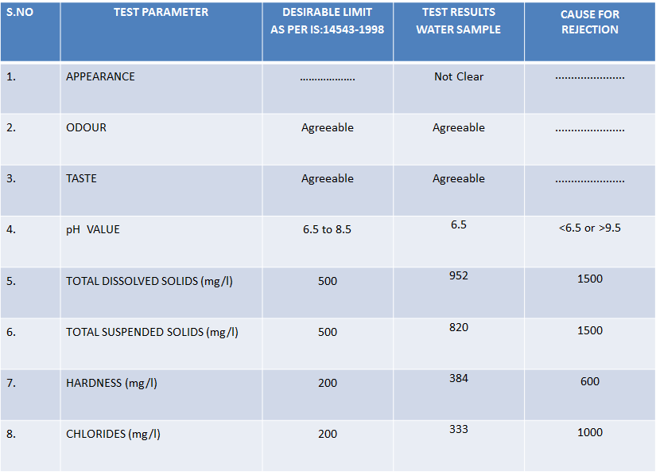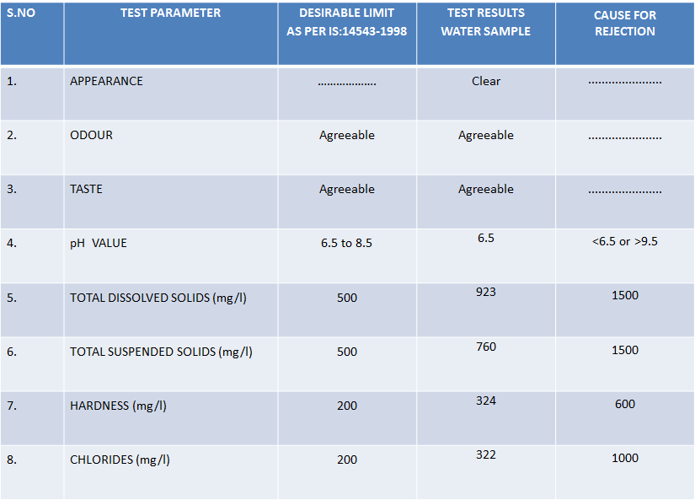**

**Area 5**

**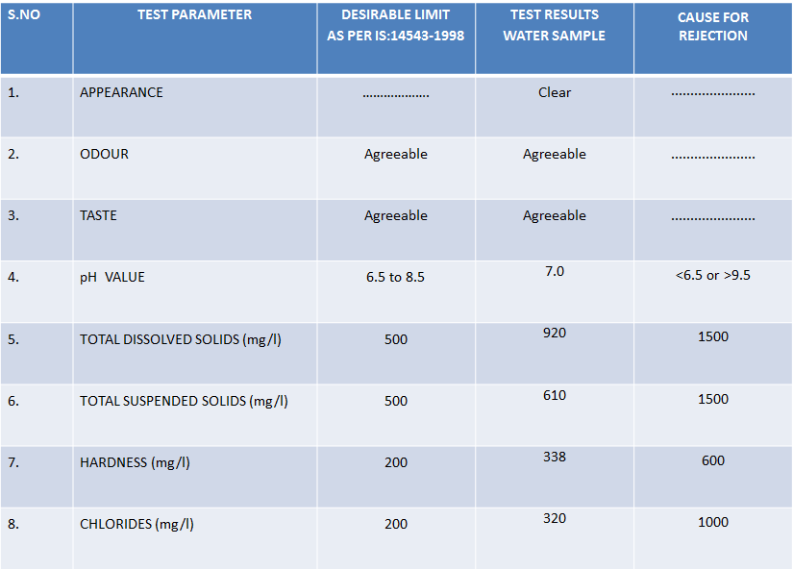**

**Autonagar Total Area Test Results**

**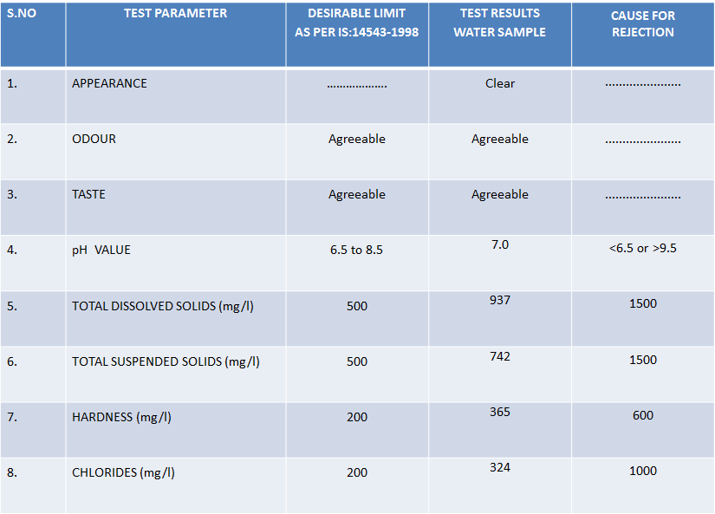**

**TEST RESULTS OF AYYAPPANAGAR WATER SAMPLE:**

**Sub: Test Results of Water Sample for drinking purpose-reg.**

**The Results are tabulated below:**

**Sanath Nagar**

**Siddik Nagar**

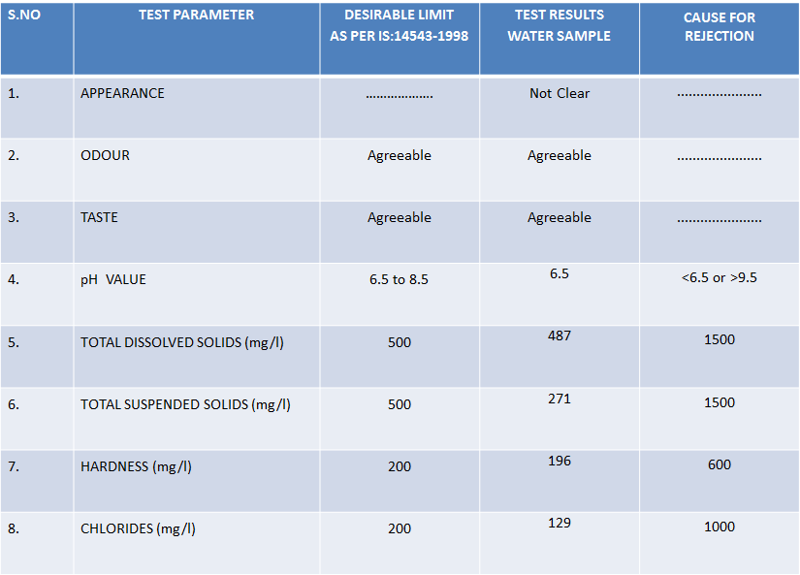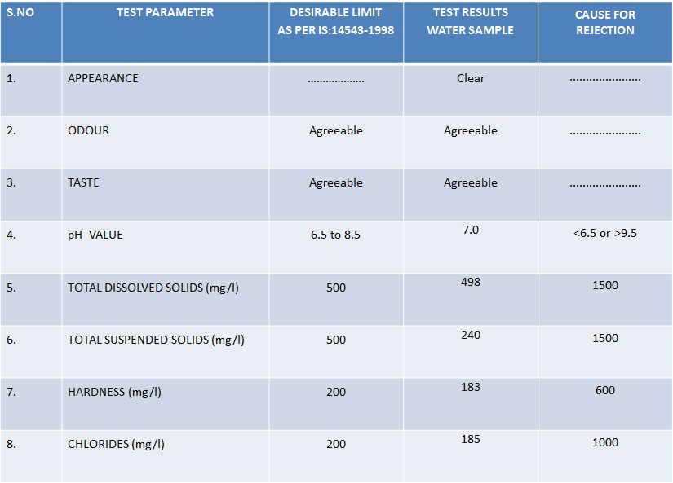

**Tulasi Nagar**

**Ayyappa Nagar Area 1**

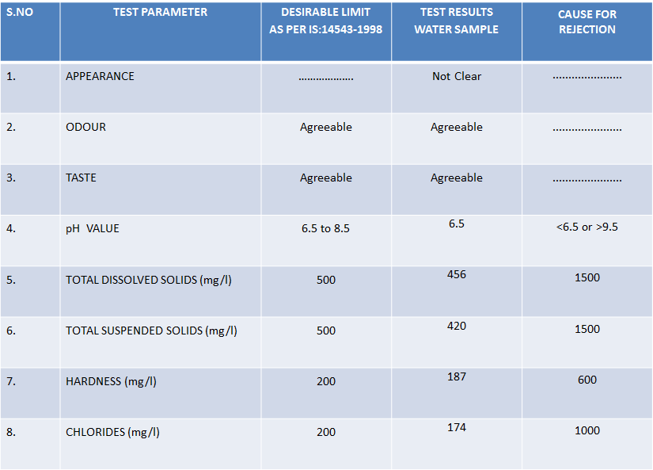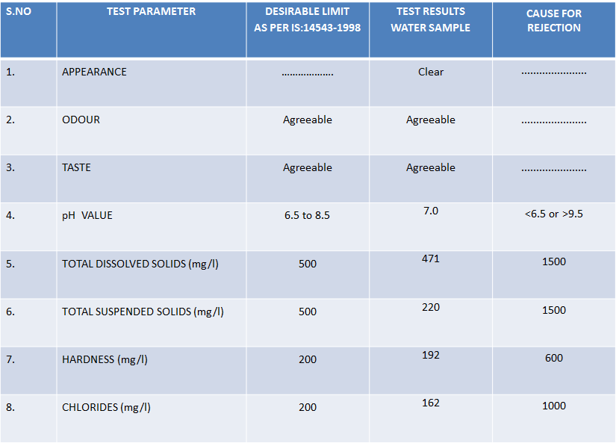

**New RTC Colony**

**Ayyappa Nagar Area 2**

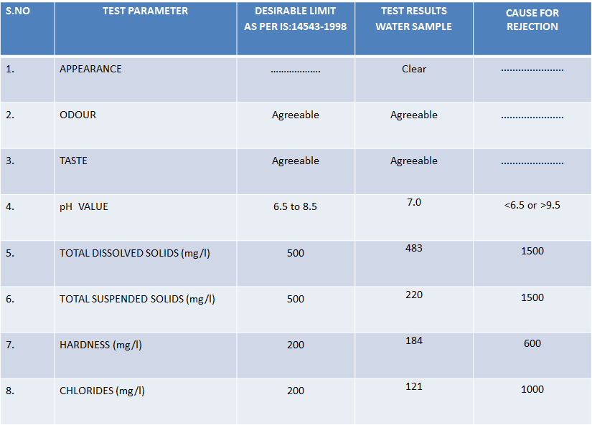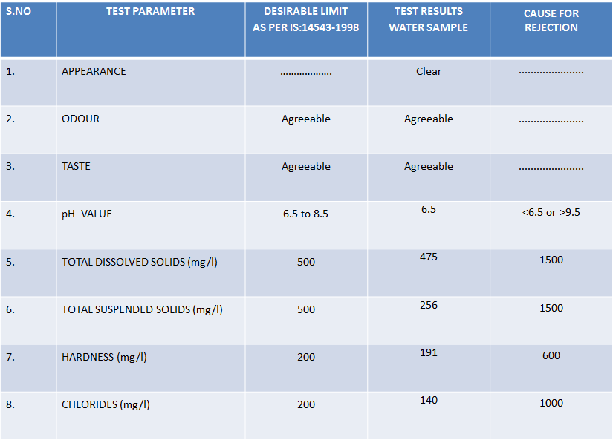

**Ayyappa Nagar Total Area Test Results**

**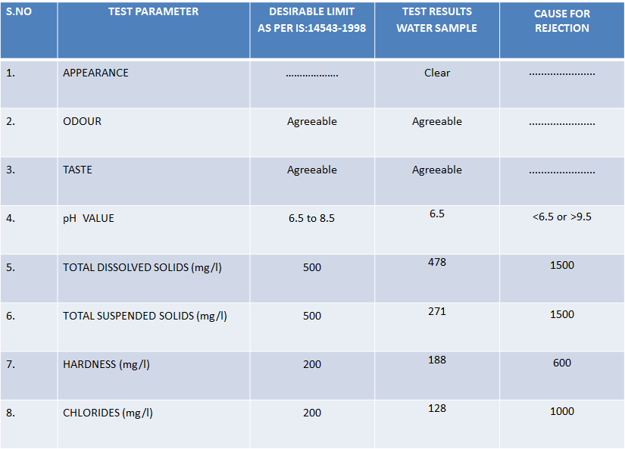**

**TEST RESULTS OF PATAMATA WATER SAMPLE:**

**Sub: Test Results of Water Sample for drinking purpose-reg.**

**The Results are tabulated below:**

**High School Road Area**

**Ramchandra Nagar**

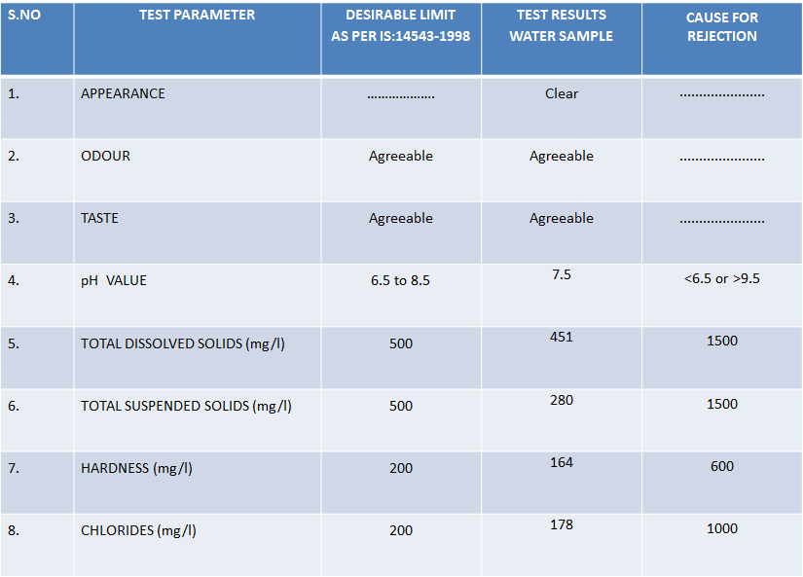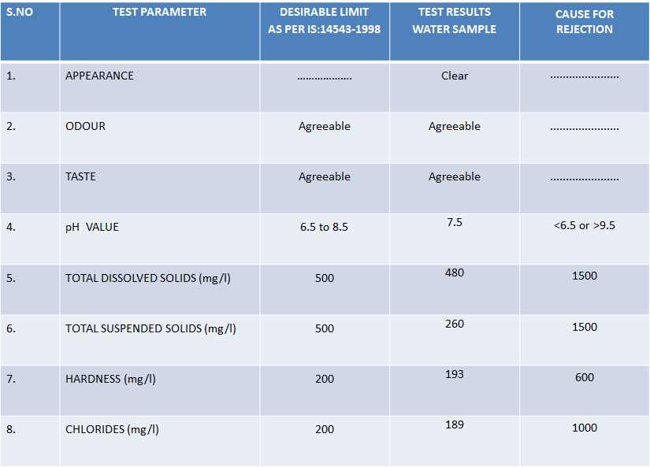

**J D Nagar**

**Thotavari St.**

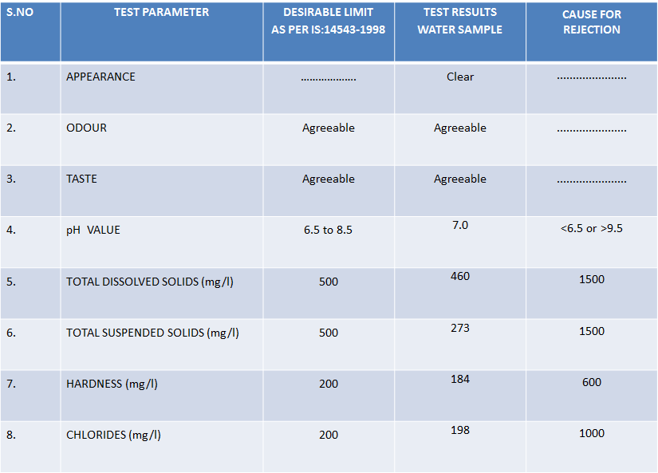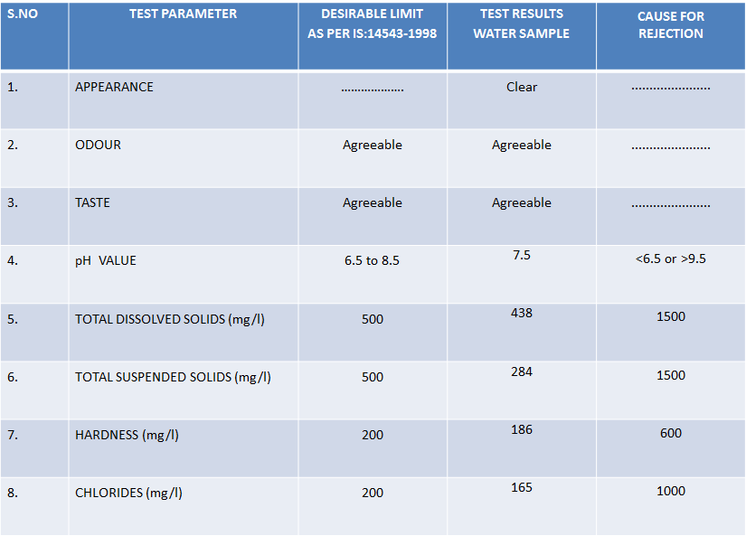

**Darsipeta**

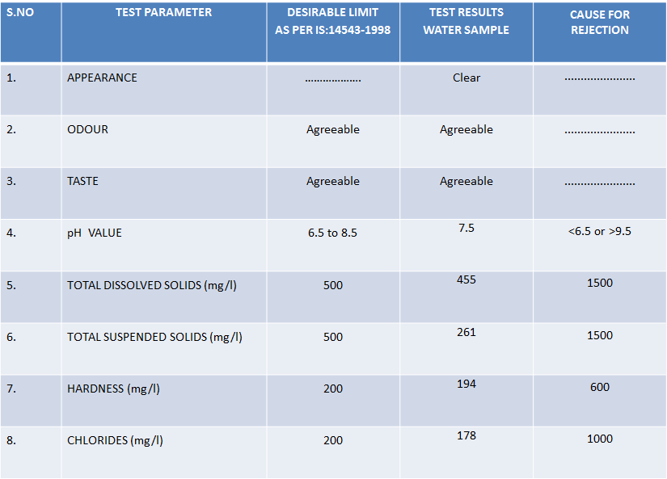

**Patamata Total area Test Results**

**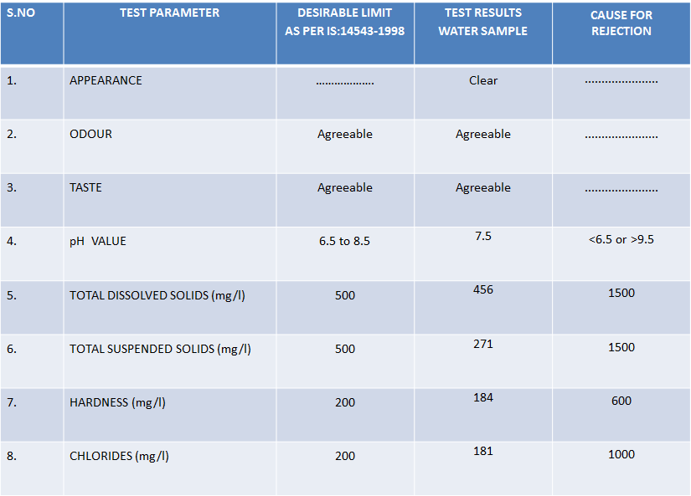**

**TEST RESULTS OF BENZCIRCLE WATER SAMPLE:**

**Sub: Test Results of Water Sample for drinking purpose-reg.**

**The Results are tabulated below:**

**Sriram Nagar Area 2**

**Sriram Nagar Area 1**

**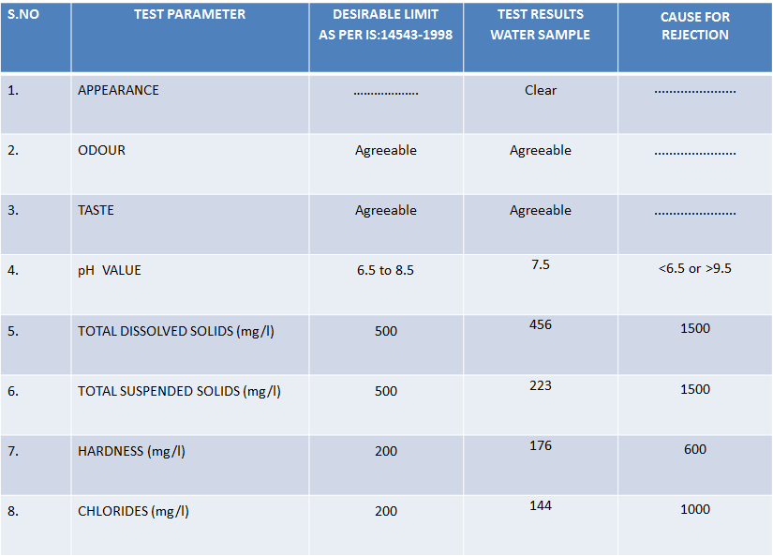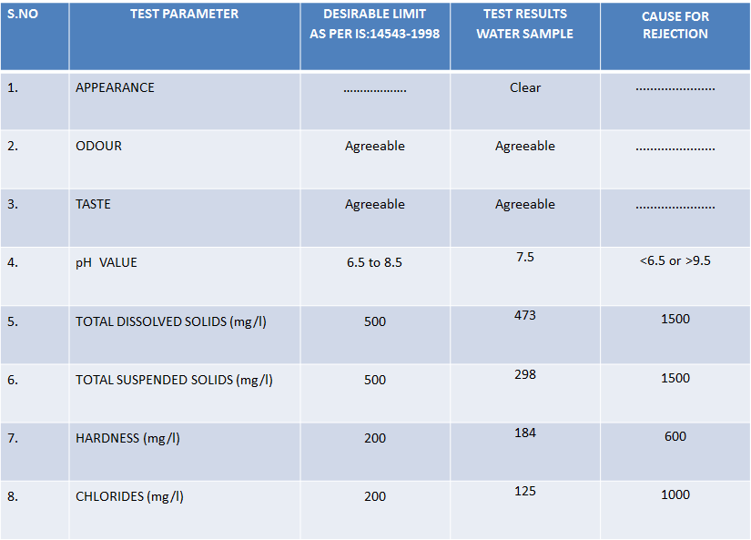**

**Patamata Lanka**

**N.S.M School Area**

**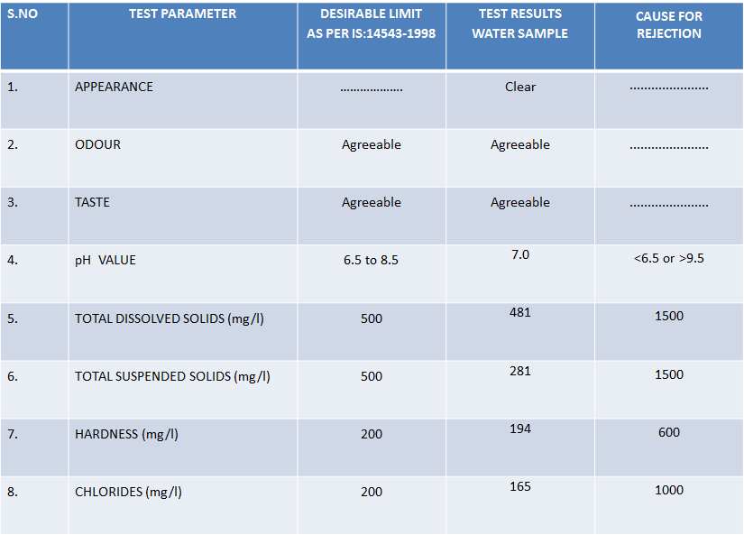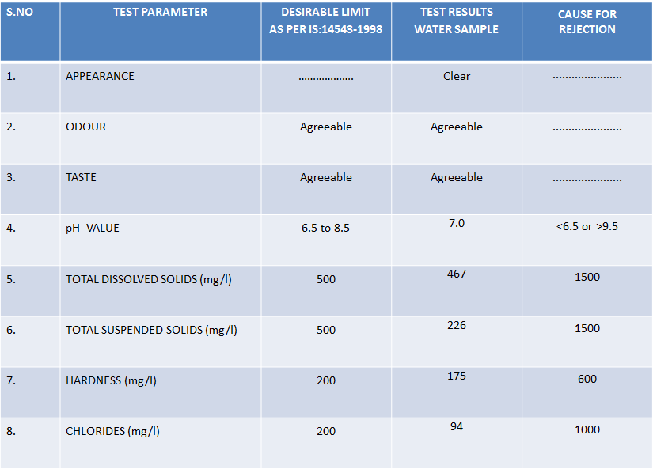**

**AcharyaRanga Nagar**

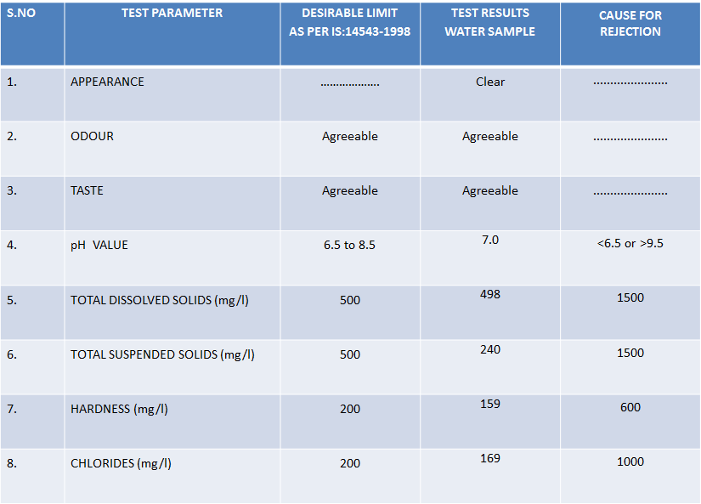

**Benz Circle Total Area Test Results**

**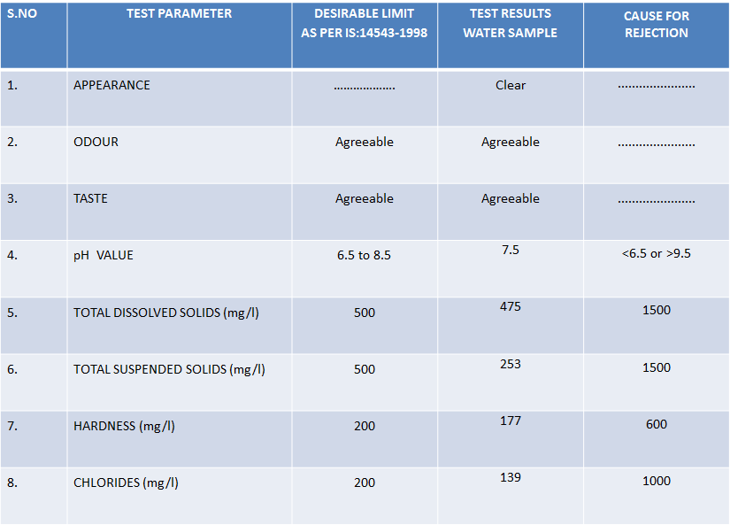**

**TEST RESULTS OF LABBIPET WATER SAMPLE:**

**Sub: Test Results of Water Sample for drinking purpose-reg.**

**The Results are tabulated below:**

**Shanti Nagar Area**

**Giripuram Area**

**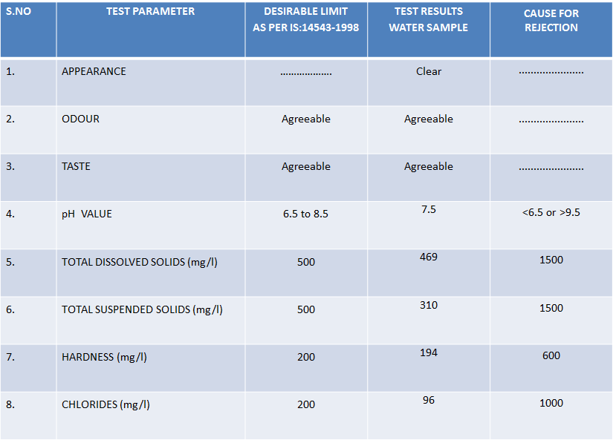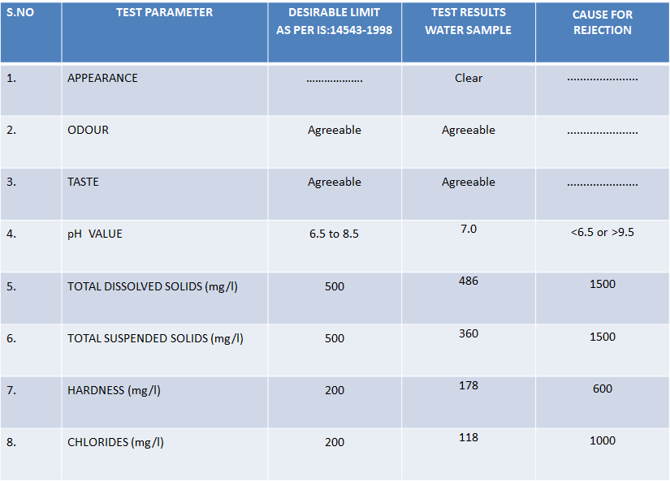**

**PVR Mall Area**

**Siddhartha Nagar Area**

**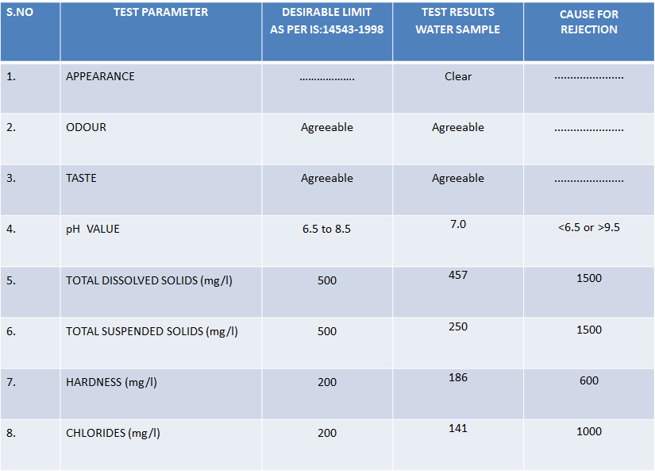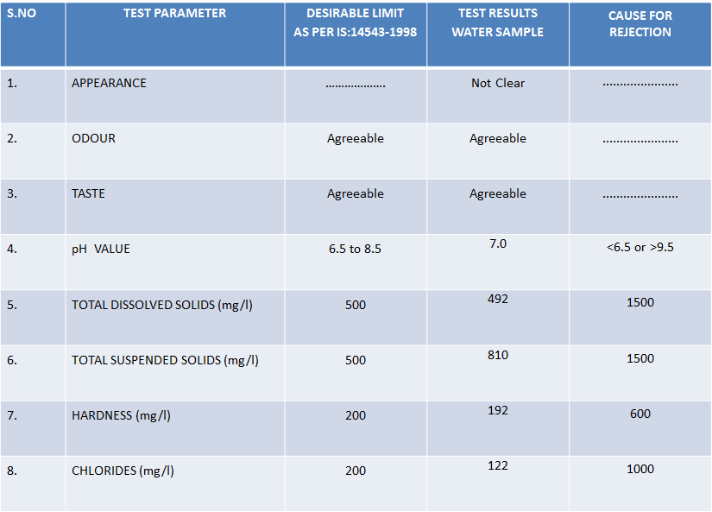**

**Labbipet Centre Area**

**Punammathota Area**

**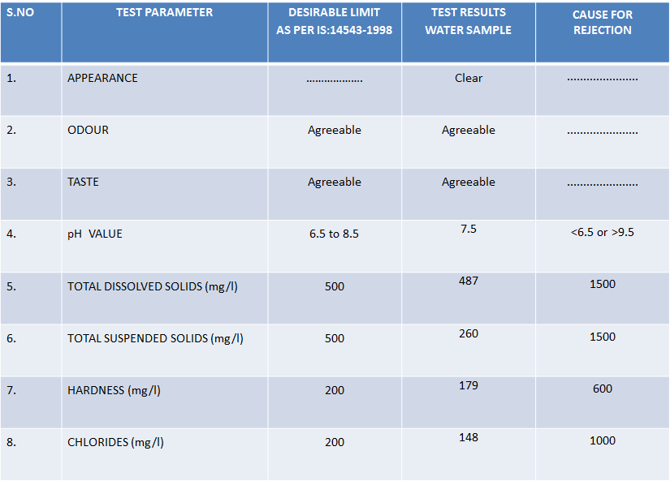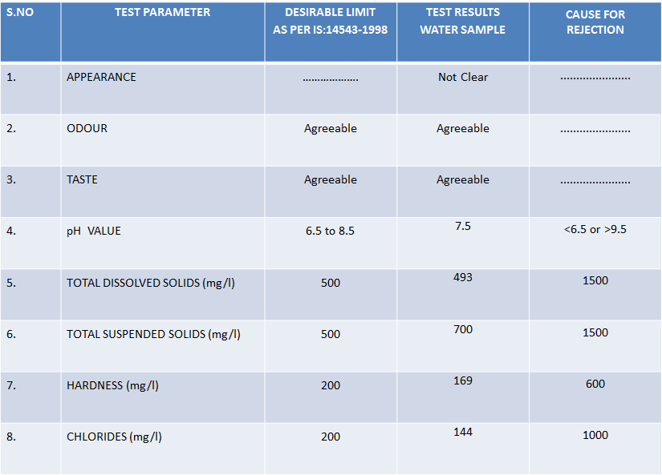**

**Labbipet Total Area Test Results**

**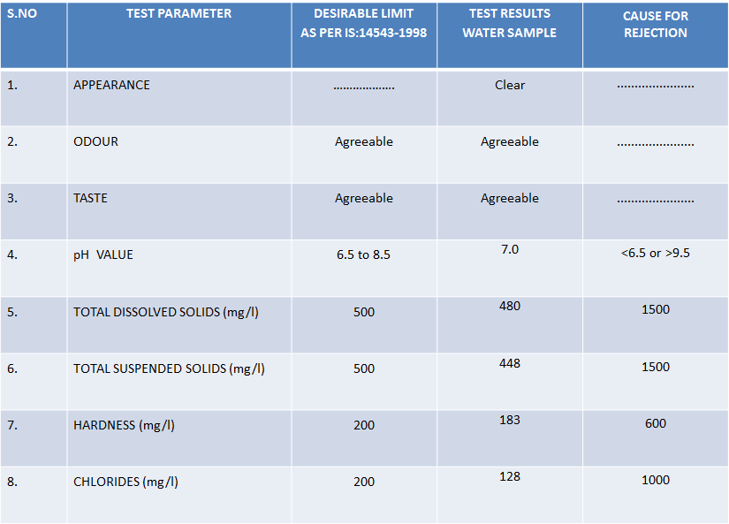**

**TEST RESULTS OF GUNADALA WATER SAMPLE:**

**Sub: Test Results of Water Sample for drinking purpose-reg.**

**The Results are tabulated below:**

**Siddhartha Medical College Area**

**Lurdhunagar Area**

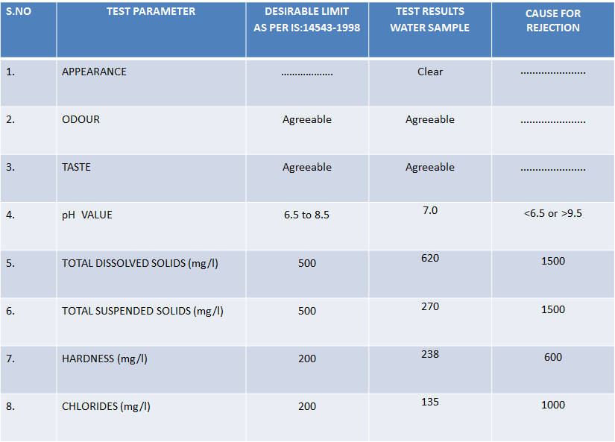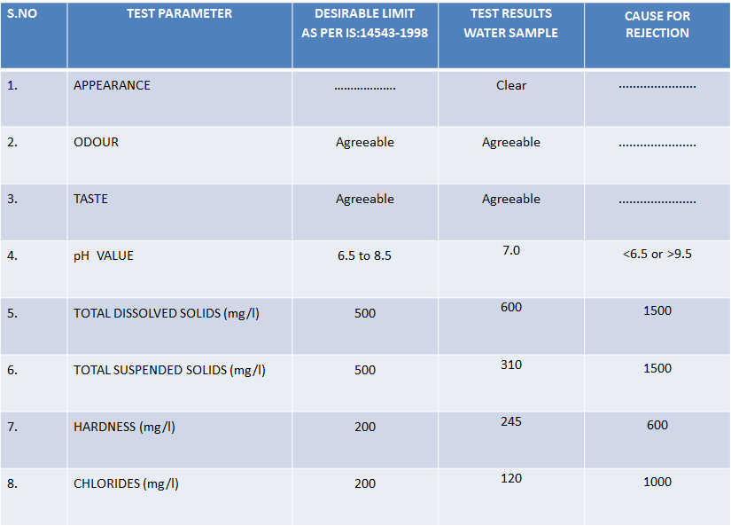

**Gunadala Total Area**

**Test Results**

**Vishnu Nagar Area**

**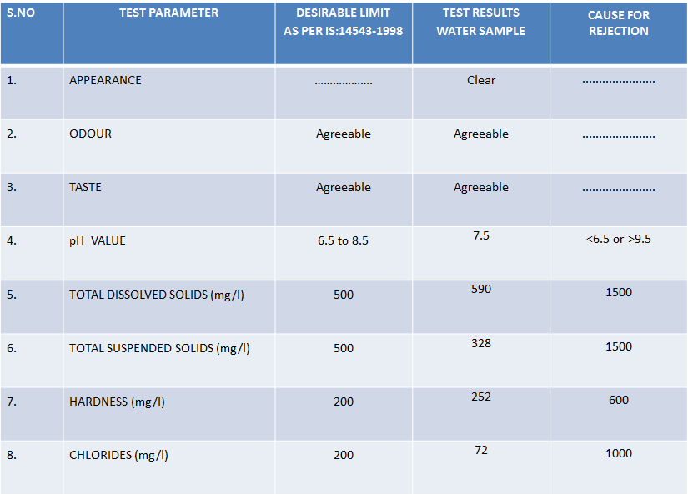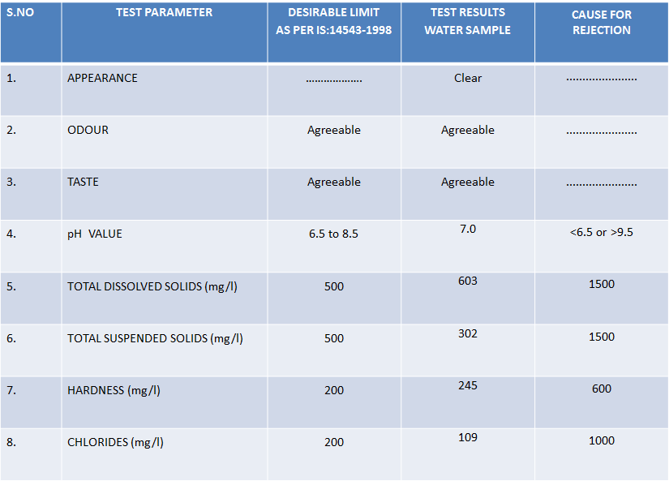**

**TEST RESULTS OF MACHAVARAM WATER SAMPLE:**

**Sub: Test Results of Water Sample for drinking purpose-reg.**

**The Results are tabulated below:**

**Machavaram Down**

**Sardar Patel St. Area**

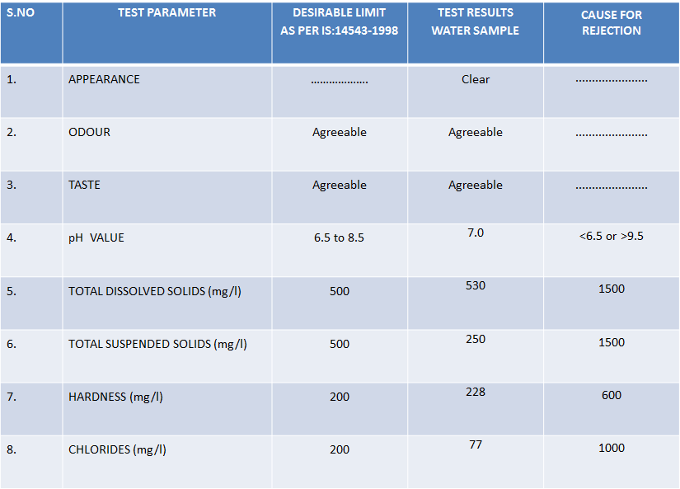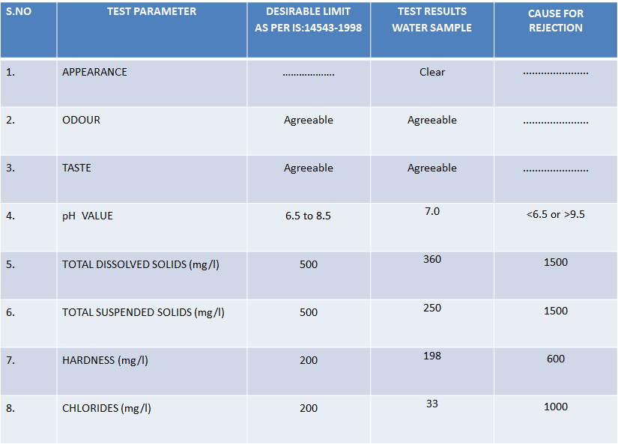

**Divine Nagar**

**Santhi Nagar**

**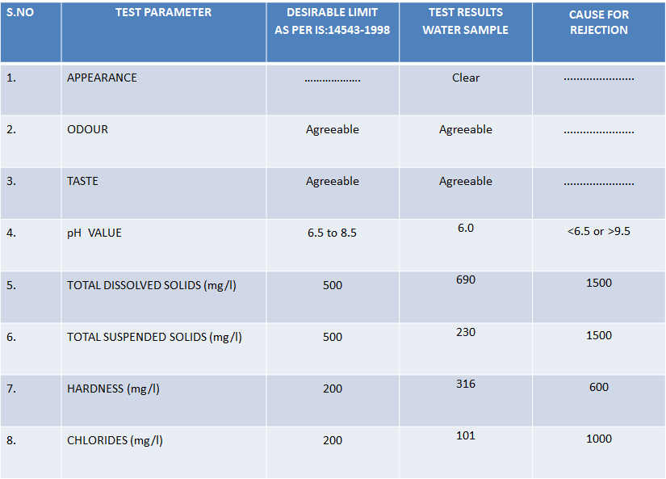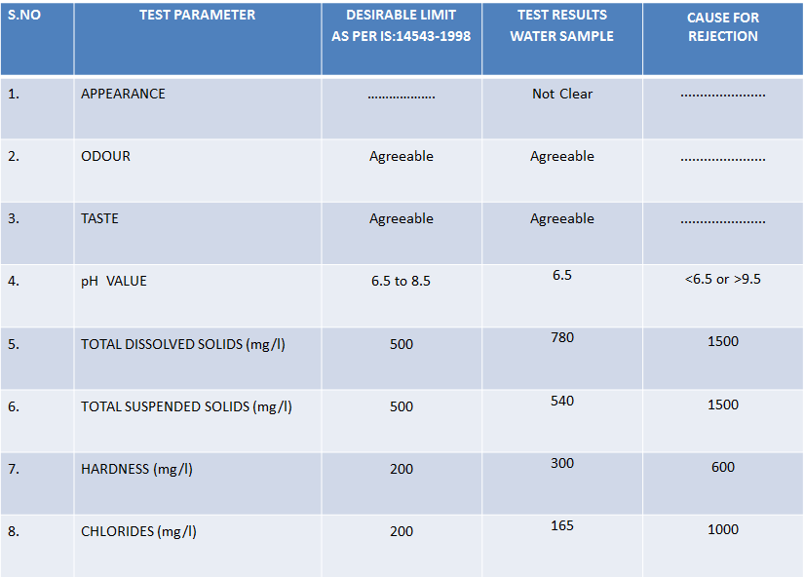**

**Maruthi Nagar**

**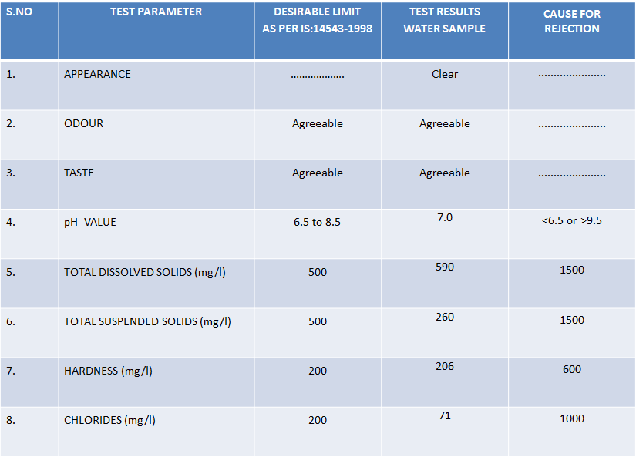**

**Machavaram Total Area Test Results**

**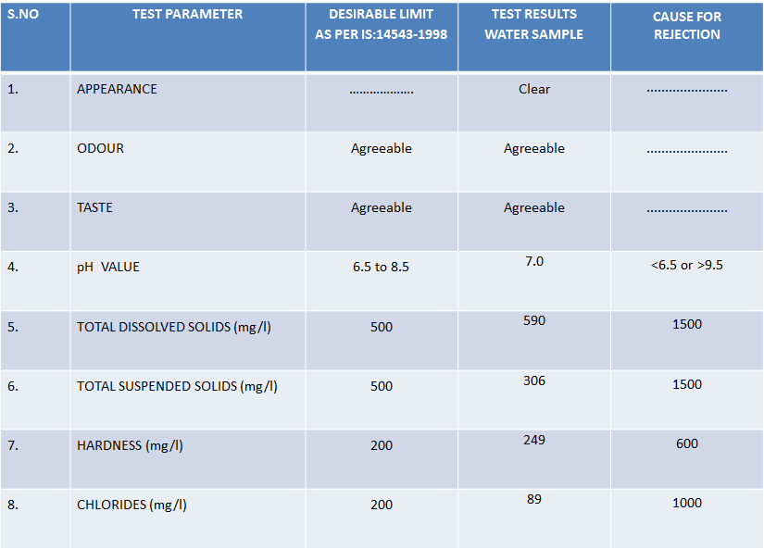**

**COLLECTION OF WATER SAMPLES**

**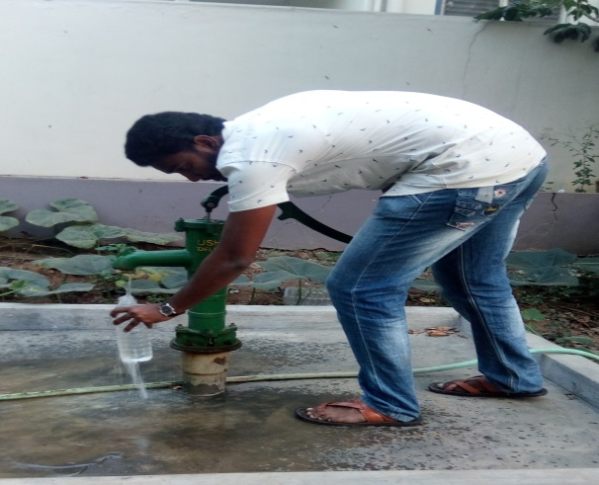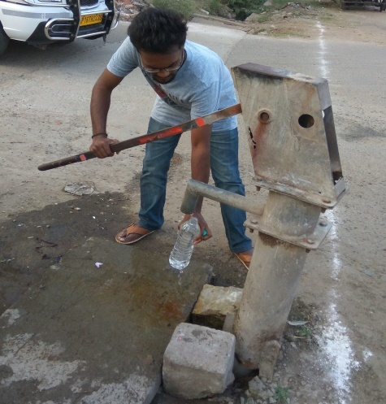**

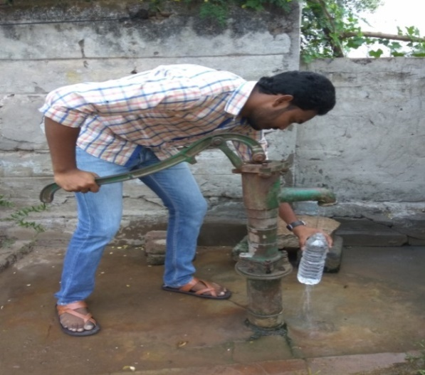 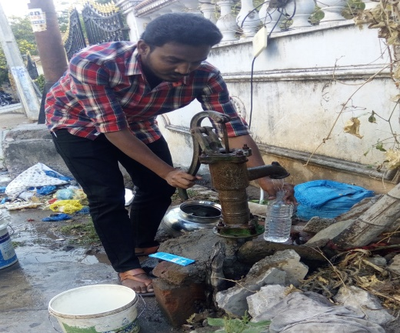

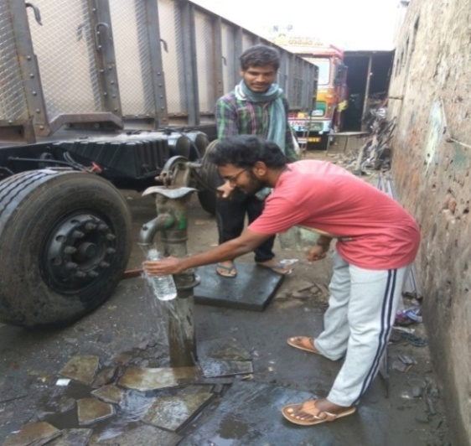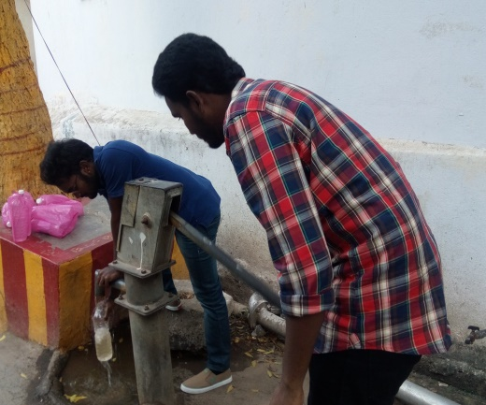

**Fig 4.1**

**TESTING OF WATER SAMPLES IN A LABORATORY**

**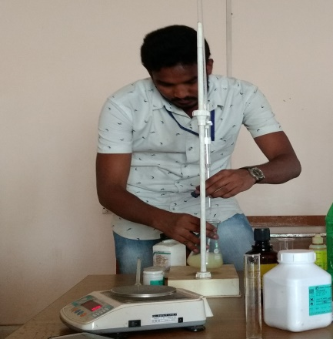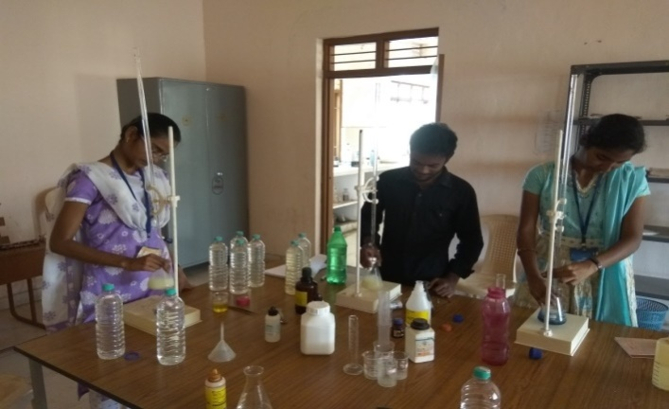**

**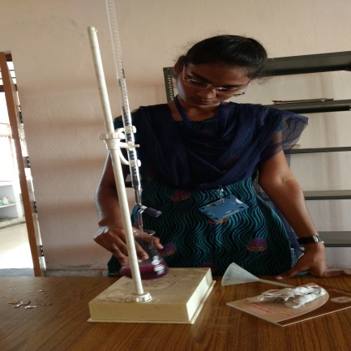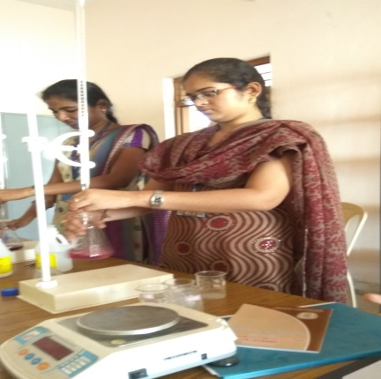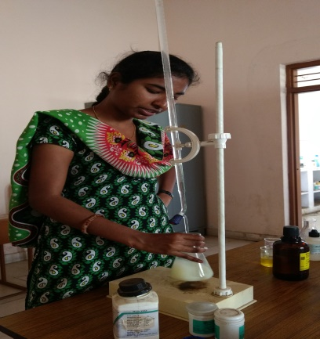**

**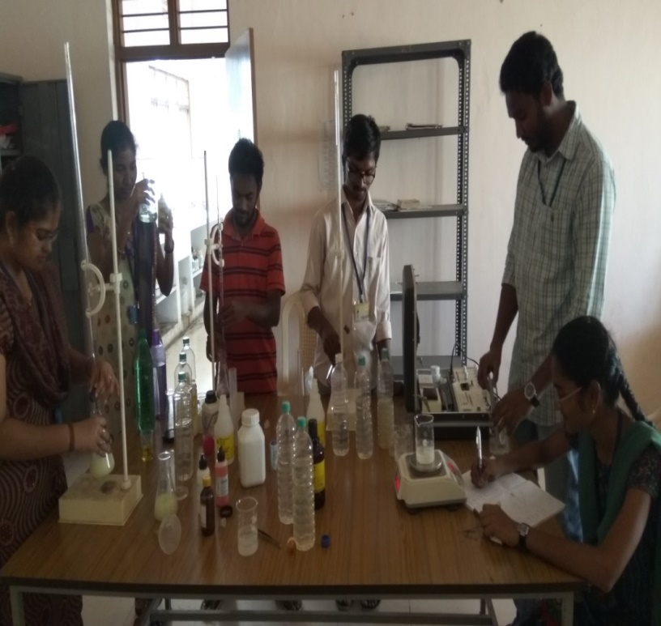**

**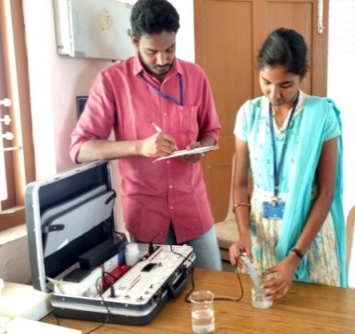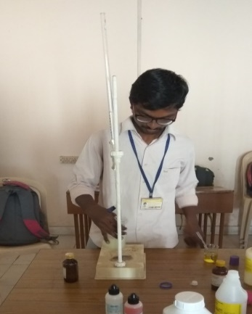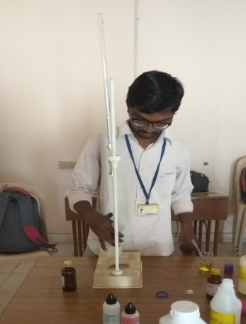**

**Fig 4.2**

**4.8. Effects and Remedies of Chemical Parameters**

**1.pH**:

The term pH is a measure of the concentration of hydrogen ions in a diluted solution. It can range from 0 to 14, with 7 denoting a neutral value. Acidic water has a pH below 7; alkaline water, above 7. The health effects of pH on drinking water depend upon where the pH falls within its range. The U.S. Environmental Protection Agency, which classifies pH as a secondary drinking water standard, recommends a pH between 6.5 and 8.5 for drinking water.

EFFECTS of pH:

* Drinking water with an elevated pH above 11 can cause skin, eye and mucous membrane irritation.
* On the opposite end of the scale, pH values below 4 also cause irritation due to the corrosive effects of low pH levels.
* At low pH values generally have few negative health effects. Acidic drinking water can cause serious problems, through the leaching of heavy metals from plumbing systems.
* Aquatic wildlife also suffer from the effects of pH extremes. Fish die-off occurs when pH levels dip below 4.5 or rise above 10.

TREATMENT FOR pH IN DRINKING WATER:

* Two home treatment methods to adjust pH are acid neutralizing filters and chemical feed pump systems injecting a neutralizing solution. An acid neutralizing filter uses a calcite or ground limestone (calcium carbonate) for normal pH correction, but could also include a blend of magnesium oxide and calcite, if the pH is very low.

**2. HARDNESS OF WATER**

EFFECTS

health effects of hard water are mainly due to the

effects of the salts dissolved in it, primarily calcium

and magnesium. To a large extent, individuals

are protected from excess intakes of calcium by a

tightly regulated intestinal absorption mechanism

through the action of 1, 25‑dihydroxy‑vitamin D,

the hormonally active form of vitamin D.

* The
* health effects of hard water are mainly due to the
* effects of the salts dissolved in it, primarily calcium
* and magnesium. To a large extent, individuals
* are protected from excess intakes of calcium by a
* tightly regulated intestinal absorption mechanism
* through the action of 1, 25‑dihydroxy‑vitamin D,
* the hormonally active form of vitamin D.
* The health effects of hard water are mainly due to the effects of the salts dissolved in it, primarily calcium and magnesium. To a large extent, individuals are protected from excess intakes of calcium by a tightly regulated intestinal absorption mechanism through the action of 1, 25-dihydroxy-vitamin D, the hormonally active form of vitamin D.
* The
* health effects of hard water are mainly due to the
* effects of the salts dissolved in it, primarily calcium
* and magnesium. To a large extent, individuals
* are protected from excess intakes of calcium by a
* tightly regulated intestinal absorption mechanism
* through the action of 1, 25‑dihydroxy‑vitamin D,
* the hormonally active form of vitamin D.
* The
* health effects of hard water are mainly due to the
* effects of the salts dissolved in it, primarily calcium
* and magnesium. To a large extent, individuals
* are protected from excess intakes of calcium by a
* tightly regulated intestinal absorption mechanism
* through the action of 1, 25‑dihydroxy‑vitamin D,
* the hormonally active form of vitamin D.
* The
* health effects of hard water are mainly due to the
* effects of the salts dissolved in it, primarily calcium
* and magnesium. To a large extent, individuals
* are protected from excess intakes of calcium by a
* tightly regulated intestinal absorption mechanism
* through the action of 1, 25‑dihydroxy‑vitamin D,
* the hormonally active form of vitamin D.
* The
* health effects of hard water are mainly due to the
* effects of the salts dissolved in it, primarily calcium
* and magnesium. To a large extent, individuals
* are protected from excess intakes of calcium by a
* tightly regulated intestinal absorption mechanism
* through the action of 1, 25‑dihydroxy‑vitamin D,
* the hormonally active form of vitamin D.
* Increased soap usage in hard water results in metal or soap salt residues on the skin or on clothes that are not easily risned off and that lead to contact irritation.

TREATMENT FOR HARDNESS

* Chemical Process of Boiling Hard Water

We can boil water to remove temporary hardness. Temporary hardness in water can be easily removed by boiling. On boiling, calcium/magnesium bicarbonate decomposes to give calcium/magnesium carbonate, which is insoluble in water. Therefore, it precipitates out.

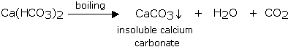

## Ion Exchange Process (Permutit Process)

## Permutit or zeolites are packed in a suitable container and a slow stream of hard water is passed through this material. As a result, calcium and magnesium ions present in hard water are exchanged with sodium ions in the permutit (Na+Al-Silicate). The outgoing water contains sodium salts, which do not cause hardness.

**3. TOTAL DISSOLVED SOLIDS**

EFFECTS OF TDS:

* At higher levels, excessive hardness, unpalatability, mineral deposition and corrosion may occur.
* At low levels, however,​TDS contributes tothepalatabilityof water.
* High TDS levels (>500 mg/litre) result in excessive scaling in water pipes, water heaters, boilers, and household appliances such as kettles and steam irons.
* High concentrations of TDS may also reduce water clarity, contribute to a decrease in photosynthesis, combine with toxic compounds and heavy metals, and lead to an increase in water temperature.

TREATMENT FOR TDS:

* Treatment for TDS content depends upon which compounds make up the dissolved solids content of an individual’s water supply.
* Excess calcium and magnesium as well as small amounts of iron can usually be removed through traditional salt-based softeners. While the overall TDS content will not be reduced, by replacing these minerals with sodium, impact of hard water will be mitigated.
* For other compounds like sulphates nitrates and sodium, a reverse osmosis or distillation system is usually needed.
* If there is high TDS content, the water treatment system is used.

**4. TOTALSUSPENDED SOLIDS**

EFFECTS:

* High concentrations of suspended solids can cause many problems for stream health and aquatic life.
* High TSS can block light from reaching submerged vegetation and as a result photosynthesis slows down.
* High TSS can also cause an increase in surface water temperature, because the suspended particles absorb heat from sunlight. This can cause dissolved oxygen levels to fall even further and can harm aquatic life

TREATMENT FOR TSS

### Gravity settling

Solid particles, because of their heavier density (compared to water) and net negative buoyant force, will settle to the bottom with a terminal velocity. After settle solids water is removed.

* Filtration

Small-diameter suspended particles by filtration process

**5. CHLORIDES:**

EFFECTS OF CHLORIDES IN WATER:

* Although chlorides are harmless at low levels, well water high in sodium chloride can damage plants if used for gardening or irrigation, and give drinking water an unpleasant taste.
* Over time, sodium chloride’s high corrosivity will also damage plumbing, appliances, and water heaters, causing toxic metals to leach into your water.
* At levels greater than this, sodium chloride can complicate existing heart problems and contribute to high blood pressure when ingested in excess.

TREATMENT OF CHLORIDES:

* Reverse Osmosis will remove 90 - 95% of the chloridesbecause of its salt rejection capabilities.
* Electro dialysis and distillation are two more processes that can be used to reduce the chloride content of water.

**Chapter 5**

**GIS APPLICATIONS**

**5.1.GIS APPLICATIONS**

* GIS is a computer based information system used to digitally represent and analyse the geographic features present on the Earth‘s surface.
* It is an organised collection of computer hardware, software, data and personnel designed to efficiently capture, store, update, manipulate, analyse and display all forms of geographically referenced information.
* It has been called an "enabling technology" because of the potential it offers for the wide variety of disciplines which deal with spatial data.
* GIS Components is an integration of five basic components, which are needed to perform GIS tasks
* People are Most important component of a GIS. People must develop the procedures and define the tasks of the GIS.
* Data The results are dependent on the availability and accuracy of data.
* Hardware Processing speed, ease of working and output of a GIS is Hardware dependent.
* Software this includes not only the actual GIS software, but also various databases, drawing, statistical. Imaging or other software.
* Procedures Analysis requires well-defined, consistent methods to produce correct and reproducible results.



**Fig 5.1 chart of GIS**

* Analysing Data
* A GIS must have the ability to answer questions regarding the interaction of spatial relationships between multiple datasets.
* Displaying Data
* There must be tools for visualizing the geographic features using a variety of symbology.
* Output
* Results of display should be able to be output in a variety of formats such as maps, reports and graphs.

**Geography**: Concerned with understanding the world’s & man’s place in it.

**Cartography**: Concerned with display of spatial information.

**CAD, CAC Computer software**: Provides techniques for data input, display and visualization, and representation, particularly in 3-dimensions.

**Mathematics**: Geometry & Graph theory are used in GIS system design and analysis of spatial data.

**Statistics**: Used to build models and perform spatial data analysis in GIS.

**Photogrammetry:** Aerial Photogrammetry deals with the photographs taken by an aerial camera on broad aircraft at different altitudes.

**Remote sensing**: Important source of geographical data by providing digital images from space.

Data editing and cleaning of GIS database can be done in 3 ways:

* Detecting and correcting errors
* Data reduction
* Edge matching and rubber sheeting

In any information system, facilities must be provided to detect and correct the errors in the database. Different kinds of errors are common in different data sources

**5.2. DIGITALISATION OF TOPOSHEET**

AIM: Creating a new shape file in the Arc MAP:

* First of all shape files are nothing but the layers that you create for your convenience using the Arc Catalog which is another profile or sub grade of this Arc MAP itself. You can able to create the following layer types in the Arc MAP. They are poly lines, points, polygons. polylines are generally used for the streams, Roads, Embankment trench lines for observing landslides, points will be for the towns pr Ground control points that you may be observing during the survey such as the benchmark and all, polygon features will be used for the closed body survey type namely forests, entire town plan, oceans, etc.
* Now I will show you how to create those shape files which you are going to work on the Raster files.w
* For that first of all you need to choose the map that is exist in the computer.
* We choose Krishna district Top sheet folder in the project batch for (GIS practice).
* For that we have to choose add data button which appears in the tool bar side with a black plus mark sign in the yellow coloured rhombus.
* That will show one window through which you can add shape files as well as the Raster features in to the Arc MAP.
* Let me include the raster form first of all then the creation of the shape files later for this existing Raster image form.
* Now click on the Krishna district Raster image and click on the add button that is appearing in the window shown below. You can also observe Add data button to the top in the above figure as I mentioned it earlier already.
* After adding Map will open up in the Arc MAP software.
* Now how to create the shape files is the very next duty we should perform.
* Go to the Arc Catalog Icon and press on it. Arc Catalog icons yellow coloured icon which will appear like the yellow colored desk with a blue blanket in a shelf that is opened from it. Later if will show one window which is most commonly your explorer window in the computer. Click in the folder for the option new in which you will be allowed to create the shape file as point, line, polygon shape files.
* A point shape file is used to represent a place or thing that by its nature doesn’t have area or length, such as a mountain peak or a lighting strike, point features have point geometry.
* Click on Edit in the shape file button that is appearing to you in the above window now.
* Another window will open and it will appear as follows. Here you have to do some simple steps and that is mentioning the map for which you have created these shape file. Now press on select button to choose the coordinate system type.
* Choose the projection and press add button in that window,
* Now go to the import button and click on it. Now browser for the Map which you have added to the Arc MAP for the working in your computer path in that window and choose that map by browsing through the Import window and set that Map as the parent for the shape file which you have created, I am working with Krishna district
* We should browser to the folder where you want to create the shape file and right
* so I have to give it in the Import via Browsing and add that detail to the every shape file which I have created for the Krishna district.
* The same step will continue for the every shape file which you have created in the Arc Catalog menu.
* Now shape files will be created using this process and they will be stored in a place where you browsed and created via Arc Catalog. Don’t forget where you have created the shape files because that will become a panic if you forget so and we have to create them again.
* But this is one way of creating shape file and there is also another way known as the feature class and Database creation method. Both will have more or less same functionally so I prefer this one to follow rather than that method.
* After you choose the projection type for the shape file and the Raster image you imported then they obey the curvature properties basing on the grid coordinate system that you choosed, and every measurement on the feature you draw using the editor will be measured basing on the coordinate system that you allot to the image and the shape files.
* I intend in creating the shape files Roads, contours in the folder Krishna district Workout in my computer, but when giving the image on which you are working out as source for the shape file you created make sure that the image is in theimg form but not the .bmp, .jpeg .tif form.
* If you did not know how to rectify the image and make it ready for the shape file let me help by mentioning them also in the Geo-image rectification.
* You should know how to enter the coordinate for the entire tiff image you choosed. Especially four coordinate points must be given at the square border of the toposheet for the rectification of the image.

**Clip the.img format image:**

* Clipping of the image means simply trimming the unnecessary side borders of the image except the area that is within the coordinates you entered. Clipping can be of many types not only rectangular or square. You can also clip an image in the desired closed polygon shape that you want. But all will follow the common procedure i.e., clipping the image in .img format with the Arc Tool box window tools.
* Import the .img image only in to the Arc MAP.
* Go to the Arc tool box window which is the Red coloured icon next to the Arc Catalog icon the tool bar.
* Click on it and it will be displayed opened in the same window after click it. It has many tools. But our operation is dealing with the Raster image format but not spatial image format and all. So find for the Raster editing tool in that Tool window.
* Path for the clipping of the image is Arc toolbox>Data Management tools>Raster>Raster processing>clip.
* Click on the clip and it will open window again. In which you have to give the .tiff format of the image that you want to clip, img format of the image you want to clip and also you should be verifying the path clearly for the clipped image saving. It will most probably save the clipped image in the folder where .img file is existing. Otherwise you can also give the path were you want to save the clipped file for. I hope you get this one with no doubt.
* You can clearly observe at show the coordinates that are entered by you after choosing the .img image that has to be clipped in the Arc MAP. I have rectified my error to 0.000000 so I have the accurate coordinates being displayed there. If you have error then basing on that error it will display coordinates but not the exact.
* Just click on Ok and clipped image is saved in the address that is mentioned in output Raster Dataset in the above window displayed.
* Automatically clipped image will be imported in to your existing Arc MAP window. You can verify whether it is clipped or not them.
* This window suggests the process that image is under process of being clipped.

**Final step**: Digitalization of the image:

* For the digitalization of the image import the clipped image, shape files created in to the Existing Arc MAP working window.
* Now after the adding data i.e., shape files and the .img format clipped image, we have to start the editing.
* Make the editor toolbox appear in the window that you are working in.
* That editor toolbox will be looking like as follows.
* Press Editor>start editing. All the Icons in it will be highlight.
* Choose the pencil tool as displayed above and always select the shape file on which you are working in. Suppose if it is roads, select the feature as the roads in the scroll menu that is provided at the end.
* Use the pan tool to move to the sides when you are working with the editing.
* To have the edits up to mark you should pressF2function key for one time or you should select save edits in the editor scroll in the editing tool bar. Every time when you save editing, stop the edit by click on stop editing and can able to view your work progress in Digitalization by switching off Raster image in the layers.
* But be careful when you are working with the polygon features because if you double click at the any point then the whole loop will be closed from start point to ending point without further modification of the shape of the polygon.
* And save this entire digitalization in. mxd form in the hard drive by your name or top sheet name in your own folder. You can save your work by clicking in the save in the file menu of the main bar. You are allowed to choose the directory where you have to save the .mxd format Arc INFO file.
* Give some name like Krishna district digitalization .mxd for the entire digitalization work in the Arc MAP software.
* So that whenever you want to continue the editing you can directly enter the editing by clicking that file in the directory and you can again start editing from where you have saved your last edits.
* Make up the entire editing of the different shape file that you have created by using the start editing, save editing and stop editing. Also in the mainframe of Arc MAP you have to save the entire project or work by pressing the ctrl+S in favorable time. It is huge editing and power was cut off then edits cannot be retained back to the system.
* During the editing on snapping in the editor scroll so that you have the line get intersected correctly at one point near the junctions without intersect to each other. After Digitalization of the Map you can observe and correlate with the Raster map which you used for the Digitalization.
* You can also updated the changes in the digital form very easily if there are any changes in the Raw image or the toposheet on which you have already digitalized. That is the fore more important use of the digitalization.
* It serves as a soft copy for the Map source of the Toposheet in the vector form namely points, polylines and polygons.
* So many features like buffering, Town planning can be organized by the help of these digitalized maps in the Arc MAP.
* So with this Digitalization we can be able to know the amount of the forest area to be cropped for the laying of the new roads or we can simple develop some new routes in the existing survey plan to reduce the traffic volume and also make population density of the places vary from one place to the other easily in a convincible manner.
* Hence we successfully completed task of digitalization of the Raster image that is Toposheet.

**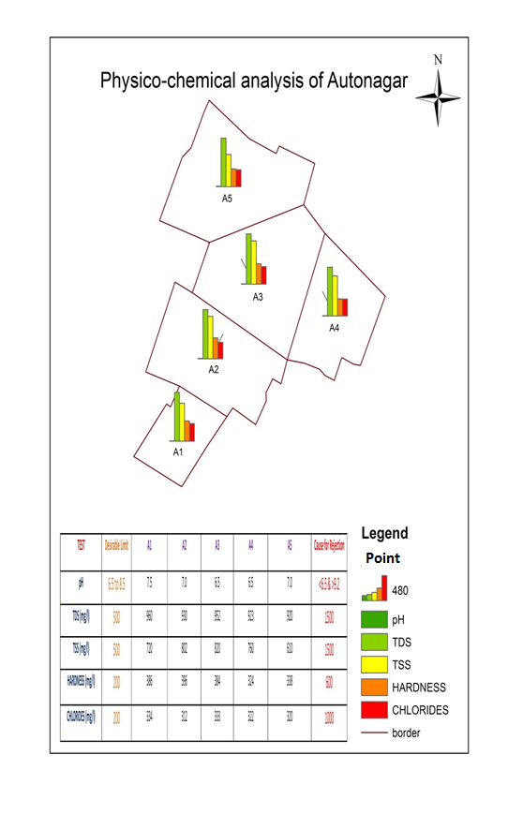Fig 5.2**

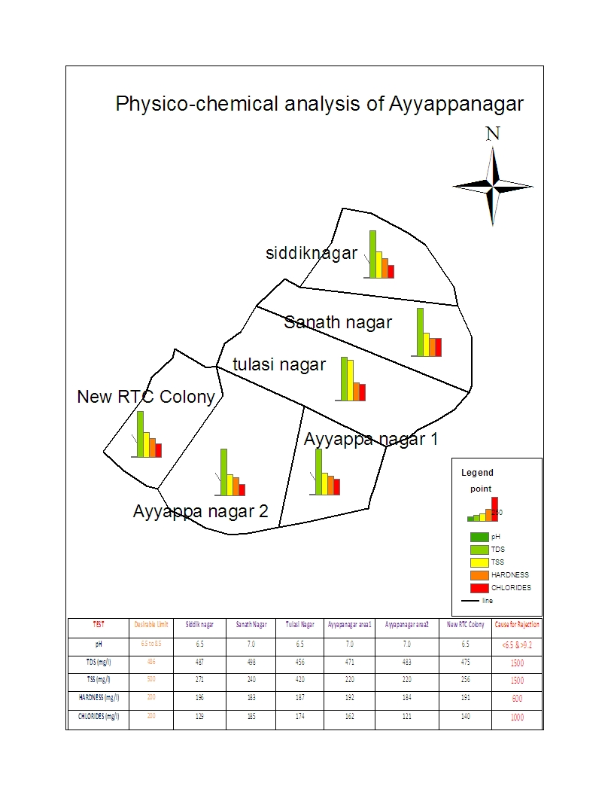

**Fig 5.3**

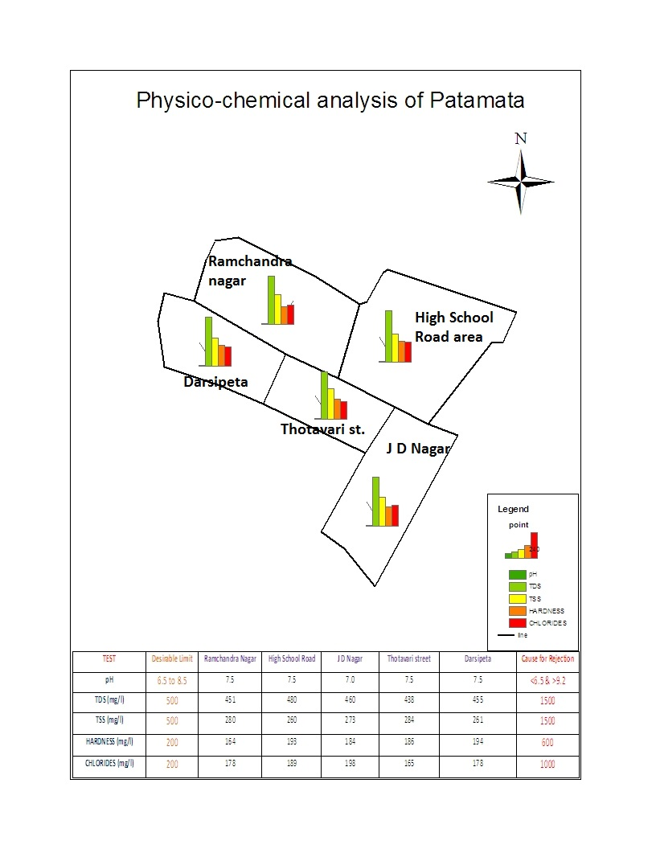

**Fig 5.4**

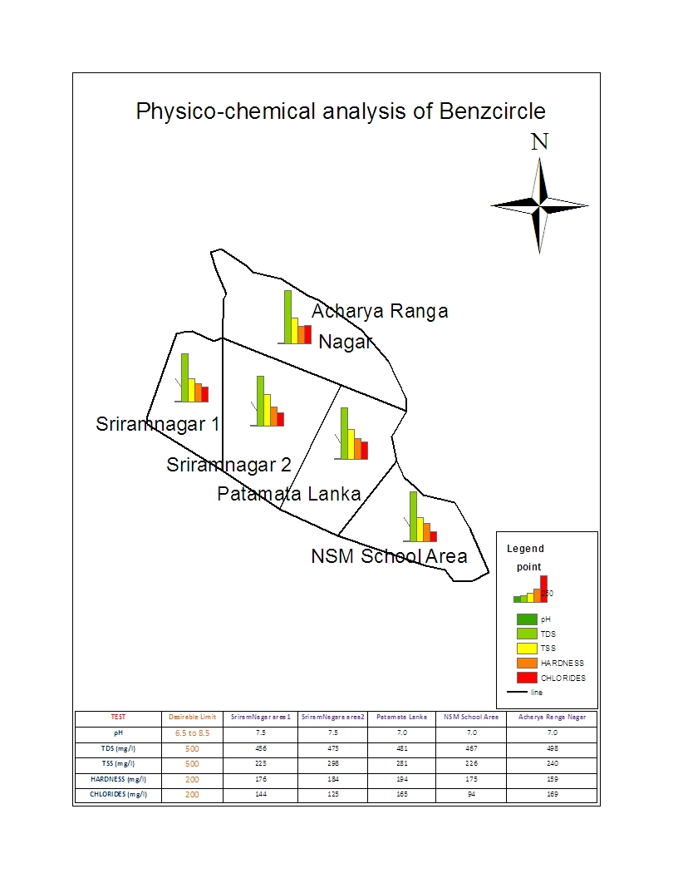

**Fig 5.5**

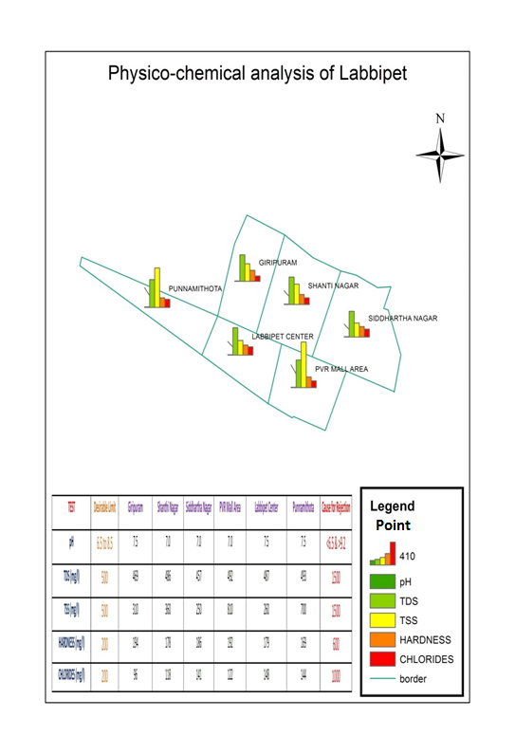

**Fig 5.6**

**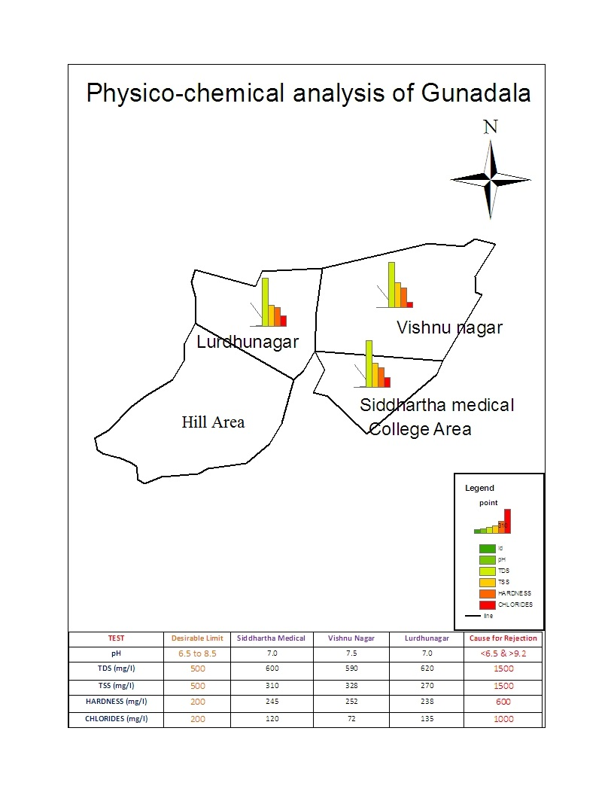Fig 5.7**

**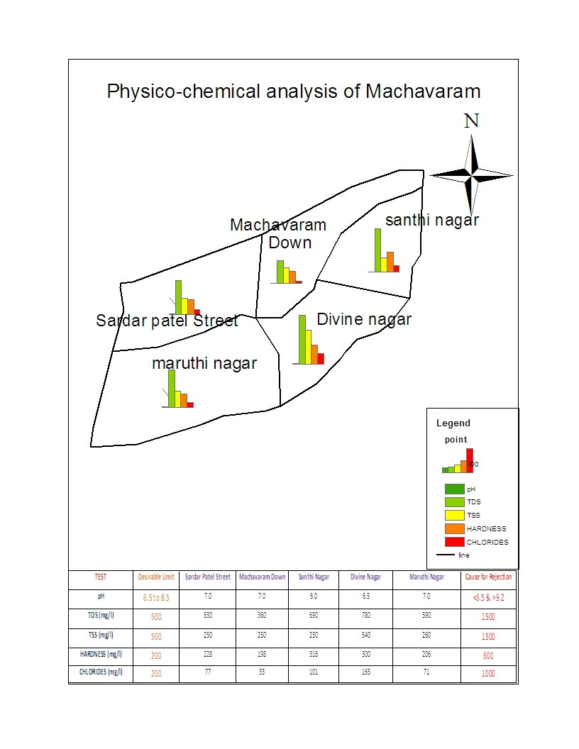Fig 5.8**

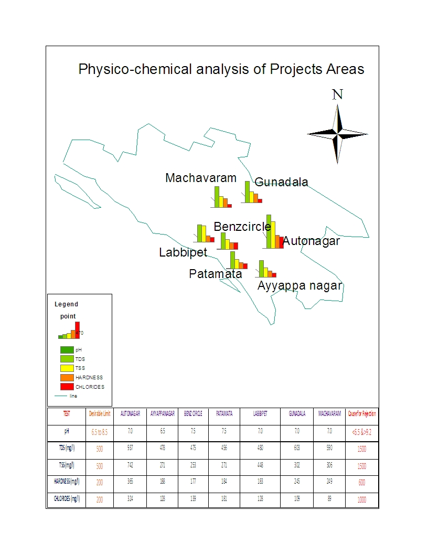

**Fig 5.9**

**Chapter 6**

**CONCLUSIONS**

**Conclusions**

* The present study of ground water in **Autonagar, Ayyappanagar, Patamata, Benzcircle, Labbipet, Gunadala and Machavaram** with a comprehensive of the parameters is studied.GIS helps in data capture and processing and it serve as powerful computational tools that facilitate multi map integrations. GIS also creates a computer interface required to carry out such studies in future.
* Ground water estimates and monitoring should be constantly done. With the help of GIS mapping we are able to show the ground water quality physico-chemical analysis of **Autonagar, Ayyappanagar, Patamata, Benzcircle, Labbipet, Gunadala and Machavaram** Ground water is safe and good drinking water.
* This study has shown that the use of GIS is very useful tool for the assessment of ground water quality.
* Geographical Information system technology must be used in their assessment of pollution as it useful to analyse & get the solution easily with more accuracy.
* The spatial distribution maps of pH, TDS, TS, TSS, Hardness, Chlorides shows that these parameters are above the permissible limit in the study area.
* People can use the ground water in **Ayyappanagar, Patamata, Benzcircle, and Labbipet** for drinking.
* **Autonagar, Gunadala and Machavaram** water is not suitable for Drinking purpose and only suitable for domestic & irrigation purpose in the study area.
* Finally it is concluded by using GIS technology has great potential to revolutionize ground water monitoring and management in the future. Rapidly expanding GIS technology will play a central role in handling the voluminous spatio-temporal data and their effective interpretation, analysis and presentation, through GIS applications.

**References**

1. Anjaneyulu.Y, Introduction to Environmental Science, Edition, B.S Publications, Hyderabad, 2004.
2. AnjiReddy.M, Text book of Remote Sensing and Geographical Information systems, Second edition, B.S Publications, Hyderabad, 2001.
3. Chemical analysis of water and soil a laboratory manual by Dr.KVSG Murali Krishna, 2008.
4. John Wiley & Sons fundamental of GIS by Mechanical Designs.
5. Kang – Tsungchang GIS, TMH Publications & co. MC Donnell, Oxford Publishers 2004.
6. Kumar S, Basics of Remote sensing & GIS by Laxmi Publications.
7. K.V. SeshagiriRao, Watersheds comprehensive development, B.S Publications, Hyderabad.
8. Master Plan Approach: Efficacy and Alternatives– Town and Country Planning Organization, Ministry of Urban Affairs and Employment, Government of India,1997
9. Water Supply Engineering – Santosh Kumar Garg, Khanna Publications, 1998.
10. Web Sites:

[www.google.com](http://www.google.com)

[www.googleearth.com](http://www.googleearth.com)

[www.gisdevelopment.net](http://www.gisdevelopment.net)

[www.mapsofindia.com](http://www.mapsofindia.com)

<http://ga.water.usgs.gov>

<http://gis.esri.com>

[www.nrsa.gov.in](http://www.nrsa.gov.in)